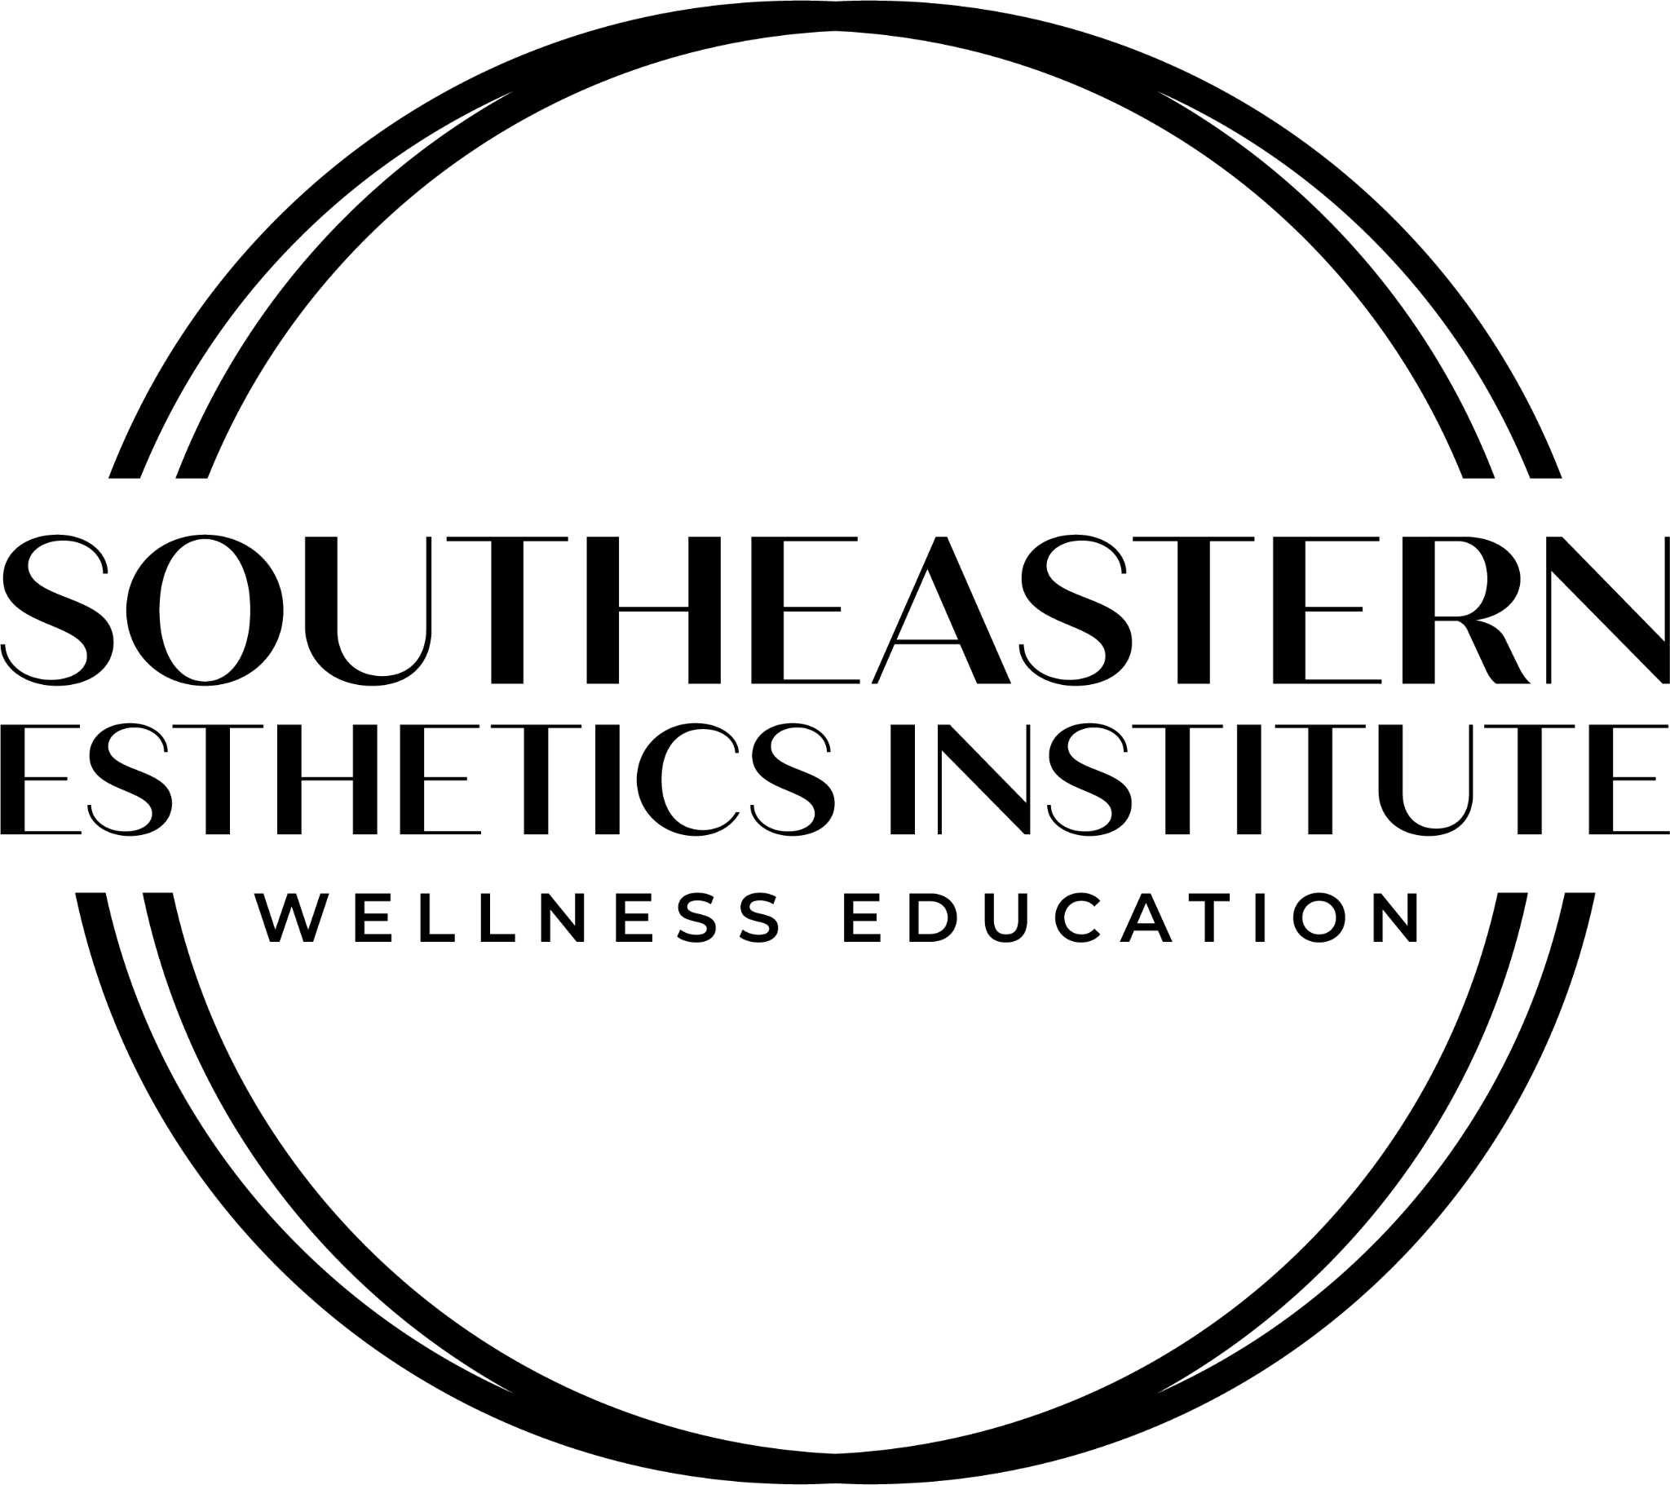

Student Catalog 2023
Your Life. Your Career. Your Passion.

501 Spears Creek Church Road
Elgin, SC 29045
CONTACT
(Phone) 803-814-1772 (Email) info@seestheticsinstitute.com
Website: www.seestheticsinstitute.com
REVISION08/25/2023
THE FUTURE OF ESTHETICS EDUCATION 5
INSTITUTIONAL MISSION 5
GOVERNING PRINCIPLES 5
INSTRUCTIONAL FACILITIES & GOVERNING AGENCIES 5
EQUIPMENT 6
SPA & TRAINING CENTER 7
ORGANIZATIONAL STRUCTURE CHART 7
ESTHETICS LICENSURE COURSE 7
Course Description 8
Course Objectives 8
Course Outcomes 8
Tuition, Fees & Program Costs 8
2023 Esthetics Licensure Course Program Costs 9
Admissions Requirements & Procedures 9
Pre-Requisites 10
Priority Enrollment for Veterans: Esthetics Licensure Course 10
Course Start Dates 10
Bring First Day 12
ADVANCED ESTHETICS ACADEMY 12
Course Description & Outline 12
Advanced Esthetics Academy: Schedule 12
Clinical Curriculum & Labs 13
Course Objectives 13
Course Outcomes 13
Tuition, Fees & Program Costs 14
Admissions Requirements & Procedures 15
Pre-Requisites 15
Enrollment Contract 16
Priority Enrollment for Veterans: Advanced Esthetics Academy 16
Course Start Dates 16
COSMETOLOGY: HAIR, SKIN + NAILS SCIENCES PROGRAM 17
Course Description 17
Course Objectives 17
Course Outcomes 17
Tuition, Fees & Program Costs 17
2023 Cosmetology: Hair, Skin + Nails Sciences Program Costs 18
Pre-Requisites 22
Priority Enrollment for Veterans: Cosmetology Program 23
Course Start Dates 23
Bring First Day 24
NAIL TECHNOLOGY PROGRAM 24
Course Description 24
Course Objectives 24
Course Outcomes 24
Tuition, Fees & Program Costs 25
2023 Nail Technology Program Costs 25
Admissions Requirements & Procedures 26
Pre-Requisites 27
Priority Enrollment for Veterans: Nail Technology Program 28
Course Start Dates 28
Bring First Day 28
MASSAGE THERAPY PROGRAM 29
Course Description 29
Course Objectives 29
Course Outcomes 30
Tuition, Fees & Program Costs 30
2023 Massage Therapy Program Costs 31
Admissions Requirements & Procedures 31
Pre-Requisites 32
Massage Therapy Program: Requirements of Students 33
Priority Enrollment for Veterans: Massage Therapy Program 34
Course Dates 34
Bring First Day
34
GRADING POLICY 35
INSTRUCTIONAL METHODS 35
TRANSFER STUDENTS 36
STUDENT RECRUITMENT 36
HOLIDAY SCHEDULE 36
ATTENDANCE POLICY 36
Attendance Policy per Student Contracted Schedules 36
Absences & Tardies 37
Definition of Absences 38
Make-Up Hours & Attendance Percentage Policy 38
EVALUATING THE VALIDITY OF A HIGH SCHOOL DIPLOMA 38
PROGRAM COMPLETION REQUIREMENTS 39
FIRST DAY ORIENTATION 40
EMPLOYEE ASSISTANCE & PLACEMENT 40
COMPENSATION RATES FOR GRADUATES 40
RULES & REGULATIONS FOR CONDUCT 43
Disciplinary Action 44
Termination Policy 44
STUDENT RECORDS & SAFE-GUARDING POLICY 44
ADVISING & PROFESSIONAL ASSISTANCE 44
Student Grievance Policy 45
VOTER REGISTRATION 46
CONTINUING EDUCATION 46
ELITE SPA SCHEDULE: 46
Spa Scheduling Requirements 46
Rules of the Spa 47
DRESS CODE 47
SAFETY HAZARDS & PHYSICAL DEMANDS 48
OSHA Requirements 48
Evacuation Plan 49
CAMPUS PARKING 49
COMPLETION, LICENSURE & PLACEMENT RATES 49
Retention Rate 50
CAMPUS CRIME & SAFETY POLICY 50
TUITION FUNDING OPPORTUNITIES 50
WITHDRAWAL POLICY 51
Federal Student Aid: Guidelines & Policies 51
FAFSA 51
Federal Return of Title IV Funds Policy 51
Student Financial Aid Release 52
Verification of Title IV Funding 53
Eligibility of Financial Aid After a Drug Conviction 53
REFUND POLICY 53
CREDIT BALANCE POLICY 54
SPECIAL PROVISION FOR BOOKS AND SUPPLIES 54
SATISFACTORY ACADEMIC PROGRESS (SAP) 54
Quantitative & Qualitative Factors 55
Appeal Procedure 55
Probation 56
Termination Appeal Procedure 56
Reestablishing SAP 56
Reinstatement of Financial Aid 57
COMPLETION OF COURSE WITHIN DESIGNATED PERIOD OF TIME 57
MAXIMUM TIME FRAME 57
LEAVE OF ABSENCE POLICY 58
EVALUATION PROCEDURES & REQUIRED LEVEL OF ACHIEVEMENT 59
COPYRIGHT INFRINGEMENT POLICIES & SANCTIONS 59
STUDENT BODY DIVERSITY 60
STUDENTS UTILIZING VETERANS AFFAIRS FUNDING 61
SOCIAL MEDIA POLICY 62
DATA SECURITY PLAN (DSP) 64
Information Security Contacts 64
CONFIDENTIAL Data Protection 64
Privacy Statement 65

THE FUTURE OF ESTHETICS EDUCATION
The desire for anti-aging and advanced skin care services has increased at an incredible rate over the past decade and has a bright future. The demand has created a strong need for highly trained professionals focused on clinical and advanced esthetics services. Medical spas & esthetics practices have become commonplace, and the fusion of beauty and medicine has provided a number of safe and effective solutions to many common esthetics needs. The use of advanced technology creates a specific and often significant enhancement to the client’s physical appearance and self-image. Southeastern Esthetics Institute has created a curriculum that is centered on the FUTURE of esthetics education by focusing on the in-depth studies of clinical esthetics, through an intense focus of skincare from a cellular perspective. Our small classes allow individual attention to each student. The main objective of the highly trained and experienced staff and faculty at SEEI is to assist each student in realizing their full potential in the clinical esthetics industry, allowing them to achieve their educational goals - and create a career and life they love.

INSTITUTIONAL MISSION

OUR MISSION IS SIMPLE:

TO PRODUCE TOP QUALITY, LICENSED PROFESSIONALS WITH EXCEPTIONAL KNOWLEDGE FROM A SCIENTIFIC AND CLINICAL LEVEL - IN ORDER TO OBTAIN GAINFUL EMPLOYMENT AND MAKE A DIFFERENCE IN THE LIVES OF THEIR CLIENTS.

GOVERNING PRINCIPLES
Southeastern Esthetics Institute supports its mission statement by adhering to the following governing principles:
Maintains facilities that are clean, modern, and well-equipped | Regularly review and update the curriculum to ensure that SEEI provides the most up-to-date and progressive education | Commit to an extensive marketing campaign to support client traffic through the Student Spa  Clinic | Ensure that students are well-prepared for state board examinations by offering well-organized, detailed instruction and on-going mock testing
Employ experienced, licensed and dynamic instructors | Maintain a student operated, on-campus Student Spa Clinic that provides the public with access to the most advanced spa services in  a modern, beautiful  facility | Maintain an open environment that allows students to have access to all faculty members at all times | Provide extensive support services to students - such as financial assistance, resume building, and  interview skills activities
Ensure students have access to state-of-the-art equipment, products & methodologies | Offer ongoing access to postgraduate Continuing Education through our  facility | Maintains relationships with industry experts through our Institutional Advisory Committee | Assists students through an ethical promise regarding job placement and career advancement

INSTRUCTIONAL FACILITIES & GOVERNING AGENCIES
Out of sheer passion for skin care, and by way of advanced knowledge in the medical spa industry, Southeastern Esthetics Institute was founded. Because of a serious lack in advanced education for Estheticians and the changing trends in the industry, our owner, Courtney G. Sykes, observed a niche that needed to be filled. Students will experience a level of teaching style and hands-on training that is unmatched in South Carolina. Students will come to class excited to learn - and leave class wanting to learn more!
Our modern learning facilities are located at: 501 Spears Creek Church Road, Elgin, SC 29045.
Southeastern Esthetics Institute is a licensed institution under the South Carolina LLR Board of Cosmetology, located at 101 Centerview Drive, Columbia SC 29201.
LLR Board of Cosmetology Facility License No. 1250
Southeastern Esthetics Institute is licensed by the South Carolina Commission on Higher Education, 1122 Lady Street, Suite 300 in Columbia SC 29201, Telephone Number (803) 737-2260, www.che.sc.gov. Licensure indicates only that minimum standards have been met; it is not an endorsement or guarantee of quality. Licensure is not equivalent to or synonymous with accreditation by an accrediting agency recognized by the U.S. Department of Education.
Southeastern Esthetics Institute is overseen by the Council on Occupational Education, its accreditation agency. The Council on Occupational Education is located at 7840 Roswell Road Building 300, Suite 325 in Atlanta, GA 30350.

EQUIPMENT
As part of its guiding principles, Southeastern Esthetics Institute is committed to training students with cutting-edge technology. SEEI owns all of its training equipment, including:
Microdermabrasion Machines
Venus Glow Hydradermabrasion Machines
Venus Legacy Radiofrequency Skin Tightening Machines
LED Light Shields
Hot Towel Cabinets
Hydradermabrasion Multi-Function Machines
Facial Steamer/Mag Lamp
Treatment Tables
Single Wax Pots
Double Wax Pots
Norvell Oasis (Airbrush Tanning Guns)
Norvell Airbrush Tanning Booths
Airbrush Tanning Induction Fans
Makeup Chairs
Makeup Mirrors
Trolly Carts
Ring Lights
Woods Lamps
Microchanneling Equipment
Venus Viva Machines
Alma Hybrid Laser
HArmony XL Pro Lasers
Venus Epileve Lasers
Micropigmentation Devices
Microneedling Devices

SPA & TRAINING CENTER

Our modern learning facilities are located at: 501 Spears Creek Church Road, Elgin, SC 29045.

Southeastern Esthetics Institute is a licensed educational facility under the SC LLR Board of Cosmetology, located at 101 Centerview Drive, Columbia SC 29201. LLR Board of Cosmetology Facility License No. 1227
Southeastern Esthetics Institute, located at 501 Spears Creek Church Road in Elgin, South Carolina, provides equipment and instructional material that is adequate for learning purposes. The Instructor personnel provide training of good quality and exceptional outcomes. Southeastern Esthetics Institute provides educational experiences that are impeccable in the industry and hosts directors, administrators, and instructors that have proper qualifications and fulfill their responsibilities adequately.

ORGANIZATIONAL STRUCTURE CHART

- Brandon Sykes, Chief Executive Officer | brandon@seestheticsinstitute.com
- Courtney Sykes, Chief Administrative Officer, Licensed Esthetics Instructor | info@seestheticsinstitute.com
- Erin Barbaro, Chief Admissions Officer | erinbarbaro@seestheticsinstitute.com
- Sam Nelson, Chief Financial Aid Officer | sam@seestheticsinstitute.com
- Chelsea Terry, Admissions Coordinator | chelsea@seestheticsinstitute.com
- April Schneider - Executive Assistant | april@seestheticsinstitute.com
- Kamri Nelson, Licensed Esthetics Instructor; Administrative Assistant | kamri@seestheticsinstitute.com
- Tanner Nelson, Director of Inventory and Equipment | tanner@seestheticsinstitute.com
- Brittany Roseberry, Customer Experience Manager | brittany@seestheticsinstitute.com
- Donita Lambie, Customer Care Specialist | donita@seestheticsinstitute.com
- Colton Rivers, Customer Care Specialist | colton@seestheticsinstitute.com
- Airica Howard, Customer Care Specialist | airica@seestheticsinstitute.com
- Damarah Reid, Licensed Esthetics Instructor | damarah@seestheticsinstitute.com
- Shannon Cavey, Licensed Cosmetology Instructor | shannoncavey@seestheticsinstitute.com
- Krystal Westbrook, Licensed Esthetics Instructor krystal@seestheticsinstitute.com
- Shannon Craft, Licensed Cosmetology Instructor | shannoncraft@seestheticsinstitute.com
- Paula Wessinger, Licensed Esthetics Instructor | paula@seestheticsinstitute.com
- Latisa Goodwin, Licensed Cosmetology Instructor | latisa@seestheticsinstitute.com
- Dana Porter, Licensed Cosmetology Instructor | dana@seestheticsinstitute.com
- Alexis Brown, Licensed Cosmetology Instructor | alexis@seestheticsinstitute.com
- Debra McLaughlin Ford, Massage Therapy Instructor, Licensed Esthetics Instructor | debra@seestheticsinstitute.com
- Caitlin Cousins, Massage Therapy Instructor | caitlin@seestheticsinstitute.com
- Priscilla Richardson, Registered Nurse, Educator | priscilla@seestheticsinstitute.com
- Demecia Daye, Educator | demecia@seestheticsinstitute.com
- Kayla Spencer, Educator | kayla@seestheticsinstitute.com
- Jessica Jacobs, Educator | jessica@seestheticsinstitute.com
- Jasmine Hart, Educator | jasminehart@seestheticsinstitute.com
- Ann Marie Dywer, Licensed Therapist | amdwyer@seestheticsinstitute.com
- John Grimes, Fountain Room Cafe Manager | john@seestheticsinstitute.com
- Dr. Kylann Hutchinson, Physician | drhutchinson@seestheticsinstitute.com
- Shelley Stevens, Physicians Assistant | shelleystevenspa@seestheticsinstitute.com

ESTHETICS LICENSURE COURSE

Course Description
The primary purpose of the Esthetics Licensure Course is to train the student in the manipulative skills and desirable attitudes necessary to achieve competency in the field of esthetics, as well as obtain licensure and gainful employment.

Course Objectives
To develop the personal and professional potential of students so they may enter the field as licensed professionals who will offer a quality of service that will be sought after by both clients and employers. To train students in theory and technique of a science based esthetics curriculum while preparing individuals to seek gainful employment working as estheticians or in related fields supported by the training received at Southeastern Esthetics Institute and recognized by the state including, but not limited to, facials, waxing, makeup, and airbrush makeup, lash services, chemical peels, body treatments, microdermabrasion, LED, and other techniques and treatments.
To prepare students with sufficient training in the theory and technique of esthetics to sit for the state recognized licensing exams for Estheticians.

Course Outcomes
Upon completion of the course requirements, the determined graduate will be able to:
Project a positive attitude and a sense of personal integrity and self confidence. | Respect the need to deliver worth and value within an employer/employee relationship. | Perform the manipulative skills in the area of proper facial techniques, makeup application, hair removal procedures, and lash/brow tinting. | Perform the basic analytical skills to determine the appropriate skincare and makeup services to achieve the best results to each client.
Practice effective communication skills,  visual poise, and proper grooming. | Perform the manipulative skills in the area of facial massage, facial techniques, effective use of implements, and equipment. | Apply academic and practical learning and related information to ensure sound judgment, decisions, and procedures. | To ensure continued success, the graduate will continue to learn new and current information related to the skills, trends, and methods for career development in esthetics and related career positions.

Tuition, Fees & Program Costs
STUDENT agrees to pay the school the tuition and fees for the program selected in advance at the start of the program. The school may, at its option and without notice, prevent student from attending class until any applicable unpaid balance is satisfied. The school may charge a $10.00 transcript fee for requests for transcripts to transfer to another school. The school will charge a registration fee for students transferring to the school and a reentry fee to students who have withdrawn and wish to re enter more than 30 days after termination, of $100.00. The tuition rates current at the time of reentry will apply to the balance of training hours needed for students who re enroll more than 30 days after the formal withdrawal date unless mitigating circumstances apply. The student’s tuition may be paid by cash, check, money order or through Veterans Affairs funds for those who qualify. Textbooks and Kits are supplied the first day of class for all students in attendance. The school must provide to each current student a certified transcript detailing hours obtained, completed, and for which the school has been compensated. The contract must also include: the school will provide the student with a certified transcript of earned hours within ten working days of the student’s withdrawal or graduation provided all contractual agreements have been met.

2023 Esthetics Licensure Course Program Costs
Registration Fee $100
Book Fee $700
Kit Fee $1,800
Tuition $9,500
Tuition Total $12,300

Admissions Requirements & Procedures
The school does not discriminate in its employment, admissions, instruction, or graduation policies on the basis of sex, race, age, ethnic origin, or religion. SEEI has a zero-tolerance policy towards sexual harassment, drug, or alcohol abuse within its staff, workplace and classrooms. SEEI complies with the American Disabilities Act of 1990; the school facility is wheelchair accessible. SEEI does not recruit students already attending or admitted to another school offering similar programs of study. Students must complete a Student Aptitude & Eligibility Test, compiled of simple, mathematical equations that are crucial to the business portion and advanced curriculum of our Esthetics Licensure Course, in addition to reading comprehension & writing.
All parties interested in enrollment must complete a Student Aptitude Test prior to acceptance.
Student must schedule this during the regular office hours of 8:00am-3:00pm through the Chief Admissions Officer. Southeastern Esthetics Institute holds the right to abide by this ruling, in order to maintain the most professional, career-ready students in the state.
1. Complete the Student Enrollment Contract available through the Admissions Office. The application may be requested by emailing: info@seestheticsinstitute.com
2. Read and review the Student Catalog, which can be downloaded from the institutional website, by requesting via email, or by visiting the institution.
3. Schedule a Student Interview & Facility Tour with our Chief Admissions Officer to discuss your goals in the esthetics industry, tour our modern facilities, and meet the students/staff.
4. Submit the completed Student Contract with the required $100 Registration Fee via check, cash, or credit card. The fee is an addition to the cost of tuition and is non-refundable.
5. Students are eligible at this stage to schedule a meeting with the Chief Financial Aid Officer, who serves as an authorized counselor to conduct all communications regarding tuition payments and repayments through Federal Student Aid, if utilized.
Veterans Affairs Eligibility: Individuals are allowed to attend and participate in a program of education at Southeastern Esthetics Institute if the Chapter 31 or 33 Beneficiary provides the school with a “Certificate of Eligibility” (COE)”.

Pre-Requisites
- Applicants must be at least 17-years old with a high school diploma or GED equivalent. Applicants must be a legal US citizen and have had no involvement with crimes related to drug or moral turpitude.
- Students that have attended home schooling are admitted based on South Carolina state requirements.
- Applicants must be of sound mind and good character. It takes many characteristics to become a successful Esthetician, with examples consisting of being a good listener, strong direction, and team player to excel in any esthetics career. It is preferred that students have this general understanding before beginning the course.
- Applicants must maintain strict promptness when it comes to time management during contact with the school as well as professional appearance and attitude. Applicants must possess certain life experiences that have matured the candidate, enabling them to communicate positively and effectively to clients, students, and staff.
- Applicants must also possess financial stability and thoughtful consideration as to the cost of training and how they will budget for this additional expense.
- Students will need to provide a copy of: TWO forms of government-issued identification and a copy of high school diploma/transcripts or GED equivalent. ONE FORM OF ID MUST INCLUDE A PHOTO.

Priority Enrollment for Veterans: Esthetics Licensure Course
Southeastern Esthetics Institute withholds the right to allow all Veterans and dependents of Veterans to apply and enroll within start dates as a priority above all other students during the enrollment process.

Course Start Dates
All course start-dates are subject to change - however, our general start dates for the Esthetics Licensure Course begin every five weeks, in accordance with the following breakdown.
Please request a Start-Date Calendar for the current year by email/phone. We will always keep the start dates and graduation dates current on the homepage of our institutional website at all times.
Esthetics Licensure Course - DAYTIME: Full-Time  20 Weeks Total | 30 Clock Hours per Week  Weekly Schedule Monday-Friday 9:00am-3:00pm | Esthetics Licensure Course - EVENING  30 Weeks Total | 20 Clock Hours per Week  Weekly Schedule Monday-Thursday 4:00pm-9:00pm

2023 DAY CLASS ESTHETICS LICENSURE COURSE Enrollment Dates
January 9, 2023 - May 26, 2023
February 13, 2023 - June 30, 2023
March 20, 2023 - August 4, 2023
April 24, 2023 - September 8, 2023
May 30, 2023 - October 13, 2023
July 3, 2023 - November 17, 2023
August 7, 2023 - December 22, 2023
September 11, 2023 - January 26, 2024
October 16, 2023 - March 1, 2024
November 20, 2023 - April 5, 2024

2023 EVENING ESTHETICS LICENSURE COURSE Enrollment Dates
March 6, 2023 - September 29, 2023
June 20, 2023 - January 12, 2024
October 2, 2023 - April 26, 2024

Student Kit Price List: Esthetics Licensure Course
$2700 Student Kit

Kit Item | Price
BOOK KIT:  - Milady Foundations & Fundamentals Textbook Set  - Milady Esthetics Workbook  - Borboleta Eyelash Extensions Training Manual - Virtual Book | $455.92
Chemical Peel Kit: Glycolic Peel 33%, Lactic Peel 25%, Salicylic Cream Peel | $394.00
Borboleta Eyelash Extensions Kit + Mannequin Head | $500.00
SEEI Backpack | $59.95
V-Neck Scrub Top x 3 | $44.95 or $49.95 ea. (over 3XL) = $134.85 or $149.95
Drawstring Scrub Pant x 3 | $34.95 or $39.95 ea. (over 3XL) = $104.85 or $119.85
Waxing Hair Removal Kit | $49.95
Facial Brush Set | $29.95
Brow Scissors | $24.95
Slanted Brow Tweezers | $19.95
Comedone Extractor Set | $24.95
Bio-Therapeutic BT-Vision, 2.0 Magnifying Glasses | $129.95
Makeup Brush Set | $49.95
Courtney Sykes Molecular Anti-Aging Skincare Products - Complete Skincare Kit | $730.00

Make-Up Hours & Study Hall

Southeastern Esthetics Institute provides the following opportunities for STUDY HALL on site for students to utilize as Make-Up Hours throughout the week. Study Hall locations reside in their designated THEORY classrooms with a Licensed Instructor on site.

8:00am-9:00am Monday-Friday
3:00pm-4:00pm Monday-Thursday

Spa & Theory Hours

As per the SC LLR Board of Cosmetology standards, esthetics students must complete approximately 60 hours of instruction prior to practicing/working on members of the public on the Student Clinic/ Practical Floor.
Additionally, schools offering day classes must conduct theory classes not less than six hours per week.

Bring First Day
● Highlighters, pencils, pens & plenty of paper for taking notes
● Small pencil box for storage of metal implements
● 3-inch wide, 3-ring binder with a front cover insert sleeve
● Medium pencil box for storage of facial brushes and medium-sized implements
● 100 clear, 3-hole sheet protectors
● 1 Box of 3x4 index cards
● Black, Red, Blue fine tip permanent markers

ADVANCED ESTHETICS ACADEMY

Course Description & Outline
Advanced Trainings & Certificate Courses are available to Licensed Estheticians, Registered Nurses, and Nurse Practitioners. All procedures deemed to be medical procedures in the state of South Carolina are Microneedling, Micropigmentation, Dermaplaning, Cosmetic Laser, and Medical Peels. All service providers obtaining training for those procedures will be supervised by an on-site Physician during the clinical portion of these training courses. All service providers planning to provide those services to the public are to be under the direct supervision of a Physician at all times.

Advanced Esthetics Academy: Schedule
13-Week Day Course: 300 Clock Hours
Weekly Schedule: Monday-Wednesday 8:00am-4:00pm

Clinical Curriculum & Labs
Cosmetic Lasers: IPL Laser Skin Rejuvenation | Laser Hair Removal | Hybrid + Fractional Laser Resurfacing | Tattoo Removal
Microneedling
Micropigmentation of the Brows, Eyeliner and Lip Blushing { Bonus! Areola Micropigmentation }
Medical-Strength Chemical Peels
Dermaplaning

Course Curriculum

Advanced Anatomy & Physiology of the Skin
Sterilization Techniques
Immune System
Communicable Diseases
Recognize & Refer Medical Conditions
Cosmetic Chemistry & Functional Ingredients
Performance Ingredients & Active Ingredients
Claims in Cosmetics
Sensitive Skin, Allergies & Irritants
Plastic & Cosmetic Surgery: Treating the Patient
Cosmetic Medicine & Medical Relations
The Scientific Approach

Course Objectives
To develop the personal and professional potential of students so they may enter the field as licensed professionals with advanced knowledge in specific medical modalities who will offer a quality of service that will be sought after by both clients and employers. To train students in theory and technique of a science-based esthetics curriculum while preparing individuals to seek gainful employment working as estheticians or in related fields supported by the training received by Southeastern Esthetics Institute and recognized by their state approving agency.

Course Outcomes
Upon completion of the course requirements, the determined graduate will be able to
Provide a positive attitude and a sense of personal integrity and self confidence. | Practice effective communication  skills, visual poise, and proper grooming. | Respect the need to deliver worthy service for value received in an employer-employee relationship.
Perform the manipulative skills in the areas of cosmetic lasers, microneedling, micropigmentation, and medical-strength chemical peels, and dermaplaning. | Apply academic and practical learning and related information to ensure sound judgment, decisions, and procedures. | To ensure proper continued success, the graduate will continue to learn new and current information related to the skills, trends, and methods for career development in esthetics and related career fields.

Tuition, Fees & Program Costs
Registration Fee $100
Textbook Fee $440
Kit Fee $860
Course Tuition $9,400
Total Costs $10,800
Student Kit Price List: Advanced Esthetics Academy
$1300 Student Kit ($3949.23 Value)

Kit Item | Price
BOOK KIT:  - Skincare Beyond the Basics Textbook  - Laser & Light Therapy Textbook  - Microblading Professional Manual | $499.97
Advanced Esthetics Chemical Peel Kit | $233.00
SEEI Backpack | $59.95
V-Neck Scrub Top x 3 | $44.95 or $49.95 ea. (over 3XL) = $134.85 or $149.95
Drawstring Scrub Pant x 3 | $34.95 or $39.95 ea. (over 3XL) = $104.85 or $119.85
HIRA Wireless PMU Device | $650.00
HIRA Airie Needles | $45.00
Mei-Cha Image Pigment: Black | $30.00
Mei-Cha Image Pigment: Darkest Brown | $30.00
Mei-Cha Image Pigment: Medium Brown | $30.00
Mei-Cha Image Pigment: Light Brown | $30.00
Microblading Faux Skin | $29.99
Tag 45 Numbing Agent | $39.00
Dermaplane Pro Dermaplaning Kit | $250.00

Admissions Requirements & Procedures
The school does not discriminate in its employment, admissions, instruction, or graduation policies on the basis of sex, race, age, ethnic origin, or religion. SEEI has a zero-tolerance policy towards sexual harassment, drug, or alcohol abuse within its staff, workplace and classrooms. SEEI complies with the American Disabilities Act of 1990; the school facility is wheelchair accessible. SEEI does not recruit students already attending or admitted to another school offering similar programs of study. Students must complete a Student Aptitude & Eligibility Test, compiled of simple, mathematical equations that are crucial to the business portion and advanced curriculum of our Esthetics Licensure Course, in addition to reading comprehension & writing.
All parties interested in enrollment must complete a Student Aptitude Test prior to acceptance.
Students requesting admission into the ADVANCED ESTHETICS ACADEMY must be a Licensed Esthetician, SEEI Graduate registered to take their Esthetics State Board Examinations, APRN, Nurse Practitioner, or Registered Nurse.
Student must schedule this during the regular office hours of 8:00am-3:00pm through the Chief Admissions Officer. Southeastern Esthetics Institute holds the right to abide by this ruling, in order to maintain the most professional, career-ready students in the state.
1. Complete the Student Enrollment Contract available through the Admissions Office. The application may be requested by emailing: info@seestheticsinstitute.com
2. Read and review the Student Catalog, which can be downloaded from the institutional website, by requesting via email, or by visiting the institution.
3. Schedule a Student Interview & Facility Tour with our Chief Admissions Officer to discuss your goals in the esthetics industry, tour our modern facilities, and meet the students/staff.
4. Submit the completed Student Contract with the required $100 Registration Fee via check, cash, or credit card. The fee is an addition to the cost of tuition and is non-refundable.
5. Students are eligible at this stage to schedule a meeting with the Chief Financial Aid Officer, who serves as an authorized counselor to conduct all communications regarding tuition payments and repayments through Federal Student Aid, if utilized.
Veterans Affairs Eligibility: Individuals are allowed to attend and participate in a program of education at Southeastern Esthetics Institute if the Chapter 31 or 33 Beneficiary provides the school with a “Certificate of Eligibility” (COE)”.

Pre-Requisites
- Applicants must be a legal US citizen and have had no involvement with crimes related to drug or moral turpitude.
- Applicants must be a Licensed Esthetician, Registered Nurse, or Nurse Practitioner as a pre-requisite to the Advanced Esthetics Academy. Applicants that are non licensed must provide proof of their scheduled licensing exams in order to begin the process of registration for the Advanced Esthetics Academy.
- Applicants must be of sound mind and good character. It takes many characteristics to become a successful Medical Esthetics Practitioner, with examples consisting of being a good listener, strong direction, and team player to excel in any esthetics career. It is preferred that students have this general understanding before beginning the course.
- Applicants must maintain strict promptness when it comes to time management during contact with the school as well as professional appearance and attitude. Applicants must possess certain life experiences that have matured the candidate, enabling them to communicate positively and effectively to clients, students, and staff.
- Applicants must also possess financial stability and thoughtful consideration as to the cost of training and how they will budget for this additional expense.
- Students will need to provide a copy of: One form of government-issued identification and a copy of their professional license.

Enrollment Contract
Prior to the first day of school, a meeting must be arranged to review important pre-enrollment information, including SEEI’s completion, licensure and placement rates. At this meeting and after thoroughly reading the Student Catalog, students must read and sign the Enrollment Contract prior to being fully accepted. Students will receive a copy of the completed Contract at that time.

Priority Enrollment for Veterans: Advanced Esthetics Academy
Southeastern Esthetics Institute withholds the right to allow all Veterans and dependents of Veterans to apply and enroll within start dates as a priority above all other students during the enrollment process.

Course Start Dates

2023 ADVANCED ESTHETICS ACADEMY Enrollment Dates
February 6, 2023 - May 3, 2023
March 20, 2023 - June 13, 2023
May 8, 2023 - August 9, 2023
June 20, 2023 - September 20, 2023
August 14,2023 - November 8, 2023
September 25 2023 - December 20, 2023
November 13, 2023 - February 14, 2024

COSMETOLOGY: HAIR, SKIN + NAILS SCIENCES PROGRAM

Course Description
The primary purpose of the Cosmetology: Hair, Skin + Nails Sciences Program is to train the student in the manipulative skills and desirable attitudes necessary to achieve competency in the field of cosmetology, as well as obtain licensure and gainful employment.

Course Objectives
To develop the personal and professional potential of students so they may enter the field as licensed professionals who will offer a quality of service that will be sought after by both clients and employers. To train students in theory and technique of a science based cosmetology curriculum while preparing individuals to seek gainful employment working as Cosmetologists or in related fields supported by the training received at Southeastern Esthetics Institute and recognized by the state including, but not limited to: sanitation and infection control, trichology, nail structure, chemistry, safety precautions, shampoos and rinses, scalp and hair care, hair styling, wiggery, roller placement, hair curling, nail technology, facials and skincare, state law, rules and regulations - and more!
To prepare students with sufficient training in the theory and technique of cosmetology to sit for the state recognized licensing exams for Cosmetologists.

Course Outcomes
Upon completion of the course requirements, the determined graduate will be able to:
Project a positive attitude and a sense of personal integrity and self confidence. | Respect the need to deliver worth and value within an employer/employee relationship. | Perform the manipulative skills in the area of proper hair styling, hair color, trichology, nail technology, facials and skincare, and more. | Perform the basic analytical skills to determine the appropriate hair, skin, and nail services to achieve the best results for each client.
Practice effective communication skills,  visual poise, and proper grooming. | Perform the manipulative skills in the area of hair cutting, styling, wiggery, hair color, sanitation, trichology, nail technology, facials and skincare - and more. | Apply academic and practical learning and related information to ensure sound judgment, decisions, and procedures. | To ensure continued success, the graduate will continue to learn new and current information related to the skills, trends, and methods for career development in cosmetology and related career positions.

Tuition, Fees & Program Costs
STUDENT agrees to pay the school the tuition and fees for the program selected in advance at the start of the program. The school may, at its option and without notice, prevent student from attending class until any applicable unpaid balance is satisfied. The school may charge a $10.00 transcript fee for requests for transcripts to transfer to another school. The school will charge a registration fee for students transferring to the school and a reentry fee to students who have withdrawn and wish to re enter more than 30 days after termination, of $100.00. The tuition rates current at the time of reentry will apply to the balance of training hours needed for students who re enroll more than 30 days after the formal withdrawal date unless mitigating circumstances apply. The student’s tuition may be paid by cash, check, money order or through Veterans Affairs funds for those who qualify. Textbooks and Kits are supplied the first day of class for all students in attendance. The school must provide to each current student a certified transcript detailing hours obtained, completed, and for which the school has been compensated. The contract must also include: the school will provide the student with a certified transcript of earned hours within ten working days of the student’s withdrawal or graduation provided all contractual agreements have been met.

2023 Cosmetology: Hair, Skin + Nails Sciences Program Costs
Registration Fee $100.00
Kit Fee $1270.00
Tuition $22,000
Total Tuition + Fees $24,850.00
Student Kit Price List: Cosmetology Program
$2750 Student Kit ($3014.48 Value)

Kit Item | Price
BOOK KIT:  - Milady Foundations & Fundamentals Textbook Set: Cosmetology  - Milady Cosmetology Workbook | $455.92
SEEI Cosmetology Apron | $10.00
SEEI Backpack | $59.95
V-Neck Scrub Top x 3 | $44.95 or $49.95 ea. (over 3XL) = $134.85 or $149.95
Drawstring Scrub Pant x 3 | $34.95 or $39.95 ea. (over 3XL) = $104.85 or $119.85
Waxing Hair Removal Kit | $49.95
Advanced Cosmetology Student Kit  What's Included:  Mannequin Heads  - Joanne Mannequin Head Standard Training / State Board / Premium 100% Human Hair  - Mimi Mannequin Head Advanced Training Blonde Natural Hair Growth Premium 100% Human Hair  - Deluxe Holding Clamp with 2 Extenders  Apparel  - Student Uniform (Smock) One Size - Black  - Bleach Proof Cape  - Comb Out Mini Cape  - Vinyl Shampoo Cape  Clips & Accessories  - Water Spray Bottle 16 Oz  - 12 pk Large Butterfly Clamps - Black & White  - 80 pk Double Prong Metal Hair Clips  - 80 pk Single Prong Metal Hair Clips  - 12 pk 3 1/2" Metal Duck Bill Hair Clips  Brushes & Combs  - 7" Space Tooth Finishing / Volume Comb (Krest Goldilocks G6)  - 7 3/4" Lift Comb Teaser with Steel Pick (Krest Goldilocks G8)  - 7 1/2" Extra Thin Taper / Clipper Comb (Krest Goldilocks G9)  - 7 1/4" Sectioning / Long Tooth Penetrating Comb (Krest Goldilocks G25)  - 7 1/2" Tapering / Barber Comb (Krest Goldilocks G50)  - 8 1/2" Weaving / Foiling Comb Metal Rat Tail (Krest Goldilocks G56)  - 12 pk All Purpose Combs with Inch Markers - Black (Krest Cleopatra 400)  - 12 pk Rat Tail Combs - Black (Krest Cleopatra 440)  - 1" (25 mm) Round Thermal Brush  - 1 1/4" (34 mm) Round Thermal Brush  - 1 3/4" (44 mm) Round Thermal Brush  - Round Styling Brush  - 7-Row Vent Brush  - 9-Row Rubber Base Styler Brush  - Large Paddle Brush  Scissors & Razors  - 5 1/2" Japanese Stainless Steel Cutting Shears with Removable Finger Inserts  - 27 Tooth Japanese Stainless Steel Thinning Shears  - 5 1/2" Mannequin Shears  - Hair Shaping Razor with Swivel Finger Rest  - 10 Replacement Razor Blades  - Shear Oil  - Shear Adjustment Tool  - Aluminum Storage Case  Hair Coloring & Styling  - 144 pcs Smooth Hair Rollers - Assorted  - Frosting Kit (Includes 5 frosting caps & 1 metal needle)  - Dial 60 minutes Timer  - 8 oz Applicator Bottle  - 3 doz 3/4"-Long Orange Cold Wave Rods  - 3 doz 11/16"-Long Peach Cold Wave Rods  - 3 doz 9/16"-Long Orchid Cold Wave Rods  - 3 doz 7/16"-Long White Cold Wave Rods  - 3 doz 3/8"-Long Gray Cold Wave Rods  - 3 doz 5/16"-Long Pink Cold Wave Rods  - 3 doz 1/4"-Long Blue Cold Wave Rods  - 3 doz 3/16"-Long Yellow Cold Wave Rods  - Pack of 25 Disposable Vinyl Gloves  - Tint / Color Bowl  - Tint / Color Brush  Manicure & Pedicure  - Deluxe Odorless Acrylic Sculptured Nail Student Kit containing:  - - Odorless Acrylic Liquid Monomer 0.5 fl oz  - - White Acrylic Powder .25 oz  - - Pink Acrylic Powder .25 oz  - - Nail Polish Remover 2.4 fl oz  - - Nail Cuticle Softener 2.4 fl oz  - - All Purpose Antiseptic Spray 2.4 fl oz  - - Acid Free Nail Primer 0.5 fl oz  - - Nail Glue Tube 2g  - - 20 Assorted Nail Tips  - - Glass Dappen Dish  - - Plastic Dual Dappen Dish with Caps  - - Buffing Block  - - Emery Board  - - 100 / 180 Grit Nail File  - - 30 Nail Forms  - - 3 Orangewood Sticks  - - Sable Nail Brush #6  - - Top Coat w/Sunscreen 0.45 fl oz  - Nail Acrylics Practice Hand  - 5 Pcs Nail Polish Student Set  - Manicure Brush  - 6 Pcs Manicure Implements Set  - Nail Implements Sanitizing Tray  - Manicure Bowl  - 2-Way Foot File  Electrical Appliances  - Babyliss Pro 2000W Ceramix Xtreme Hair Dryer  - 1" Babyliss Pro Porcelain Ceramic Flat Iron  - 3/4" Babyliss Pro Porcelain Ceramic Marcel Curling Iron  Totes  - 28" Jumbo Wheeled Duffel Bag with Retractable Handle | $1187.98
Barber Student Kit with Wahl 5-Star Combo Set  What's Included:  Mannequin Heads  - Marcel 16" Male Bearded Cosmetology Mannequin Head by Giell  - Deluxe Holding Clamp with 2 Extenders  Apparel  - Barber Jacket & Cutting Cape Set  - - Made of Lightweight Polyester  - - Jacket with Zippered Closure & Front Pocket  - - 42" X 58" Cutting Cape with Snap Closure  - - One Size Fits Most  Brushes & Combs  - (2) 7" All Purpose Styling Combs with Inch Markers on the back (Krest Goldilocks G4)  - (2) 7 1/2" Tapering / Barber Comb (Krest Goldilocks G50)  - * Wahl Clipper Comb included in the Barber Combo Set (not pictured)  - 9-Row Rubber Base Styler Brush  Scissors & Razors  - 5 pcs Barber Shears Kit  - - 7" Burgundy Cutting Comb  - - Straight Razor with 10 Double Edge Stainless Steel Blades  - - 7" Stainless Steel Mannequin Cutting Shears  - - 33-Tooth, 7" Stainless Steel Mannequin Thinning Shears  - - Zippered Pouch  Electrical Appliances  - Babyliss Pro 2000W Ceramix Xtreme Hair Dryer - Red  - Wahl 5-Star Barber Combo Legend Clipper & Hero Trimmer Set  Totes  - Nylon Tote Bag 19" X 12" X 10" with Pockets by Giell® | $593.98
Courtney Sykes Molecular Anti-Aging Skincare Products - Complete Skincare Kit | $417.00

Admissions Requirements & Procedures
The school does not discriminate in its employment, admissions, instruction, or graduation policies on the basis of sex, race, age, ethnic origin, or religion. SEEI has a zero-tolerance policy towards sexual harassment, drug, or alcohol abuse within its staff, workplace and classrooms. SEEI complies with the American Disabilities Act of 1990; the school facility is wheelchair accessible. SEEI does not recruit students already attending or admitted to another school offering similar programs of study. Students must complete a Student Aptitude & Eligibility Test, compiled of simple, mathematical equations that are crucial to the business portion and advanced curriculum of our Cosmetology Program, in addition to reading comprehension & writing.
All parties interested in enrollment must complete a Student Aptitude Test prior to acceptance.
Student must schedule this during the regular office hours of 8:00am-3:00pm through the Chief Admissions Officer. Southeastern Esthetics Institute holds the right to abide by this ruling, in order to maintain the most professional, career-ready students in the state.
1. Complete the Student Enrollment Contract available through the Admissions Office. The application may be requested by emailing: info@seestheticsinstitute.com
2. Read and review the Student Catalog, which can be downloaded from the institutional website, by requesting via email, or by visiting the institution.
3. Schedule a Student Interview & Facility Tour with our Chief Admissions Officer to discuss your goals in the esthetics industry, tour our modern facilities, and meet the students/staff.
4. Submit the completed Student Contract with the required $100 Registration Fee via check, cash, or credit card. The fee is an addition to the cost of tuition and is non-refundable.
5. Students are eligible at this stage to schedule a meeting with the Chief Financial Aid Officer, who serves as an authorized counselor to conduct all communications regarding tuition payments and repayments through Federal Student Aid, if utilized.
Veterans Affairs Eligibility: Individuals are allowed to attend and participate in a program of education at Southeastern Esthetics Institute if the Chapter 31 or 33 Beneficiary provides the school with a “Certificate of Eligibility” (COE)”.

Pre-Requisites
- Applicants must be at least 17-years old with a high school diploma or GED equivalent. Applicants must be a legal US citizen and have had no involvement with crimes related to drug or moral turpitude.
- Students that have attended home schooling are admitted based on South Carolina state requirements.

- Applicants must be of sound mind and good character. It takes many characteristics to become a successful Cosmetologist, with examples consisting of being a good listener, strong direction, and team player to excel in any esthetics career. It is preferred that students have this general understanding before beginning the course.
- Applicants must maintain strict promptness when it comes to time management during contact with the school as well as professional appearance and attitude. Applicants must possess certain life experiences that have matured the candidate, enabling them to communicate positively and effectively to clients, students, and staff.
- Applicants must also possess financial stability and thoughtful consideration as to the cost of training and how they will budget for this additional expense.
- Students will need to provide a copy of: TWO forms of government-issued identification and a copy of high school diploma/transcripts or GED equivalent. ONE FORM OF ID MUST INCLUDE A PHOTO.

Priority Enrollment for Veterans: Cosmetology Program
Southeastern Esthetics Institute withholds the right to allow all Veterans and dependents of Veterans to apply and enroll within start dates as a priority above all other students during the enrollment process.

Course Start Dates
All course start-dates are subject to change - however, our general start dates for the Cosmetology Program at SEEI begin every 500 clock hours, in accordance with the following breakdown.
Please request a Start-Date Calendar for the current year by email/phone. We will always keep the start dates and graduation dates current on the homepage of our institutional website at all times.
Cosmetology: Hair, Skin + Nails Sciences Program | 1500 Clock Hours | Daytime Program | 50 Weeks | 9:00AM-3:00PM - FULL-TIME
2023-2024 COSMETOLOGY PROGRAM DATES
May 1, 2023 - April 19, 2023
August 28, 2023 - August 16, 2024
January 2, 2024 - December 13, 2024

Make-Up Hours & Study Hall

Southeastern Esthetics Institute provides the following opportunities for STUDY HALL on site for students to utilize as Make-Up Hours throughout the week. Study Hall locations reside in their designated THEORY classrooms with a Licensed Instructor on site.

8:00am-9:00am Monday-Friday
3:00pm-4:00pm Monday-Thursday

Spa & Theory Hours

As per the SC LLR Board of Cosmetology standards, Schools offering day classes must conduct theory classes not less than six hours per week. No student shall be required or permitted to attend more than eight hours of instruction or practice, or any combination thereof, in any one day, except that a student may be permitted to complete a service in process or to make previously missed time not to exceed 100% of the student’s contracted schedule.

Bring First Day
● Highlighters, pencils, pens & plenty of paper for taking notes
● Small pencil box for storage of metal implements
● 3-inch wide, 3-ring binder with a front cover insert sleeve
● Medium pencil box for storage of facial brushes and medium-sized implements
● 100 clear, 3-hole sheet protectors
● 1 Box of 3x4 index cards
● Black, Red, Blue fine tip permanent markers

NAIL TECHNOLOGY PROGRAM

Course Description
The primary purpose of the Nail Technology Program is to train the student in the manipulative skills and desirable attitudes necessary to achieve competency in the field of nail technology, as well as obtain licensure and gainful employment.

Course Objectives
To develop the personal and professional potential of students so they may enter the field as licensed professionals who will offer a quality of service that will be sought after by both clients and employers. To train students in theory and technique of a science based nail technology curriculum while preparing individuals to seek gainful employment working as Nail Technicians or in related fields supported by the training received at Southeastern Esthetics Institute and recognized by the state including, but not limited to: sanitation and infection control, bacteriology, anatomy - nail shapes, structures, growth, bones, muscles, etc., nail technology, artificial nails, power equipment education, and more.
To prepare students with sufficient training in the theory and technique of nail technology to sit for the state recognized licensing exams for Nail Technicians.

Course Outcomes
Upon completion of the course requirements, the determined graduate will be able to:
Project a positive attitude and a sense of personal integrity and self confidence. | Respect the need to deliver worth and value within an employer/employee relationship. | Perform the manipulative skills in the area of proper nail technology, artificial nails, manicures, pedicures, sculpturing - and more. | Perform the basic analytical skills to determine the appropriate nail services to achieve the best results for each client.
Practice effective communication skills,  visual poise, and proper grooming. | Perform the manipulative skills in the area of nail technology, equipment use, performance of artificial nails and sculpturing, and more. | Apply academic and practical learning and related information to ensure sound judgment, decisions, and procedures. | To ensure continued success, the graduate will continue to learn new and current information related to the skills, trends, and methods for career development in nail technology and related career positions.

Tuition, Fees & Program Costs
STUDENT agrees to pay the school the tuition and fees for the program selected in advance at the start of the program. The school may, at its option and without notice, prevent student from attending class until any applicable unpaid balance is satisfied. The school may charge a $10.00 transcript fee for requests for transcripts to transfer to another school. The school will charge a registration fee for students transferring to the school and a reentry fee to students who have withdrawn and wish to re enter more than 30 days after termination, of $100.00. The tuition rates current at the time of reentry will apply to the balance of training hours needed for students who re enroll more than 30 days after the formal withdrawal date unless mitigating circumstances apply. The student’s tuition may be paid by cash, check, money order or through Veterans Affairs funds for those who qualify. Textbooks and Kits are supplied the first day of class for all students in attendance. The school must provide to each current student a certified transcript detailing hours obtained, completed, and for which the school has been compensated. The contract must also include: the school will provide the student with a certified transcript of earned hours within ten working days of the student’s withdrawal or graduation provided all contractual agreements have been met.

2023 Nail Technology Program Costs
Registration Fee $100.00
Kit Fee $700
Tuition $3300
Total $4100
Student Kit Price List: Nail Technology Program
$700 Student Kit ($1234.82 Value)

Kit Item | Price
BOOK KIT  - Milady Foundations & Fundamentals Textbook Set: Nail Technology  - Milady Nail Technology Workbook | $455.92
Gelish Master Nail Tech Student Kit  This kit includes the following:  • Nail Surface Cleanse, 4 fl. oz.  • Secure Professional Nail Adhesive Brush-On Resin, 2-count  • Harmony Professional Perfetto Nail Tips - Natural, 500-count  • Assorted Full Well Tips, Natural, 100-count  • Harmony Perfetto Nail Tips, White, 20-count  • ProHesion Master Kit  • ProHesion Nail Sculpting Liquid, 4 fl. oz.  • Odorless Monomer, 4 fl. oz.  • Harmony #7 Oval Student Brush  • Harmony Brush Cleaner, 4 fl. oz.  • Harmony Glass Dappen Dish  • Cuticle Pusher with Tabs  • Harmony Cuticle Pusher & Remover  • Toe Nail Clipper  • School Cuticle Nipper  • Exclusive School File 180/400 Grit, 12-count  • Lint-Free Nail Wipes, 300-count  • Harmony Massage Lotion, 8 fl. oz.  • Manicure Brush  • Toe Separators  • Nail Polish Remover, 4 fl. oz.  • Accelerate Quick Dry Spray, 4 fl. oz.  • React Extended Wear Base Coat, 0.5 fl. oz.  • React Extended Wear Top Coat, 0.5 fl. oz.  • Morgan Taylor Lacquer – Pretty Woman, Lip Service, Arctic Freeze, & Sweet Surrender, 0.5 fl. oz. each  • Dowel Rods, 5-pack  • Plastic Sterilizer Tray  • Tip Clip  • Wrap Material, 2 yards  • Gelish Foundation Base Gel, 0.5 fl. oz.  • Gelish Top-It-Off Sealer Gel, 0.5 fl. oz.  • Gelish CanCan We Dance? 0.5 fl. oz.  • Paddle Foot File  • Gelish Tech Bag  • Deep Manicure Bowl | $439.27
Electric Nail Drill Cordless, Rechargeable Nail File Machine with Nail Drill Bits, USB Portable Efile, Sanding Bands for Acrylic Gel Nails, Manicure Pedicure Polishing (A-Premium Pink) | $39.98
SEEI Backpack | $59.95
V-Neck Scrub Top x 3 | $44.95 or $49.95 ea. (over 3XL) = $134.85 or $149.95
Drawstring Scrub Pant x 3 | $34.95 or $39.95 ea. (over 3XL) = $104.85 or $119.85

Admissions Requirements & Procedures
The school does not discriminate in its employment, admissions, instruction, or graduation policies on the basis of sex, race, age, ethnic origin, or religion. SEEI has a zero-tolerance policy towards sexual harassment, drug, or alcohol abuse within its staff, workplace and classrooms. SEEI complies with the American Disabilities Act of 1990; the school facility is wheelchair accessible. SEEI does not recruit students already attending or admitted to another school offering similar programs of study. Students must complete a Student Aptitude & Eligibility Test, compiled of simple, mathematical equations that are crucial to the business portion and advanced curriculum of our Nail Technology Program, in addition to reading comprehension & writing.
All parties interested in enrollment must complete a Student Aptitude Test prior to acceptance.
Student must schedule this during the regular office hours of 8:00am-3:00pm through the Chief Admissions Officer. Southeastern Esthetics Institute holds the right to abide by this ruling, in order to maintain the most professional, career-ready students in the state.
1. Complete the Student Enrollment Contract available through the Admissions Office. The application may be requested by emailing: info@seestheticsinstitute.com
2. Read and review the Student Catalog, which can be downloaded from the institutional website, by requesting via email, or by visiting the institution.
3. Schedule a Student Interview & Facility Tour with our Chief Admissions Officer to discuss your goals in the esthetics industry, tour our modern facilities, and meet the students/staff.
4. Submit the completed Student Contract with the required $100 Registration Fee via check, cash, or credit card. The fee is an addition to the cost of tuition and is non-refundable.
5. Students are eligible at this stage to schedule a meeting with the Chief Financial Aid Officer, who serves as an authorized counselor to conduct all communications regarding tuition payments and repayments through Federal Student Aid, if utilized.
Veterans Affairs Eligibility: Individuals are allowed to attend and participate in a program of education at Southeastern Esthetics Institute if the Chapter 31 or 33 Beneficiary provides the school with a “Certificate of Eligibility” (COE)”.

Pre-Requisites
- Applicants must be at least 17-years old with a high school diploma or GED equivalent. Applicants must be a legal US citizen and have had no involvement with crimes related to drug or moral turpitude.
- Students that have attended home schooling are admitted based on South Carolina state requirements.
- Applicants must be of sound mind and good character. It takes many characteristics to become a successful Nail Technician, with examples consisting of being a good listener, strong direction, and team player to excel in any esthetics career. It is preferred that students have this general understanding before beginning the course.
- Applicants must maintain strict promptness when it comes to time management during contact with the school as well as professional appearance and attitude. Applicants must possess certain life experiences that have matured the candidate, enabling them to communicate positively and effectively to clients, students, and staff.
- Applicants must also possess financial stability and thoughtful consideration as to the cost of training and how they will budget for this additional expense.
- Students will need to provide a copy of: TWO forms of government-issued identification and a copy of high school diploma/transcripts or GED equivalent. ONE FORM OF ID MUST INCLUDE A PHOTO.

Priority Enrollment for Veterans: Nail Technology Program
Southeastern Esthetics Institute withholds the right to allow all Veterans and dependents of Veterans to apply and enroll within start dates as a priority above all other students during the enrollment process.

Course Start Dates
All course start-dates are subject to change - however, our general start dates for the Nail Technology Program at SEEI begin every 150 clock hours, in accordance with the following breakdown.
Please request a Start-Date Calendar for the current year by email/phone. We will always keep the start dates and graduation dates current on the homepage of our institutional website at all times.
NAIL TECHNOLOGY PROGRAM | 300 Clock-Hour Program | Monday - Friday 9:00am-3:00pm | 10 WEEKS
2023-2024 PROGRAM DATES
August 7, 2023 - October 13, 2023
September 11, 2023 - November 17, 2023
October 16, 2023 - December 22, 2023
November 20, 2023 - February 2, 2024

Make-Up Hours & Study Hall

Southeastern Esthetics Institute provides the following opportunities for STUDY HALL on site for students to utilize as Make-Up Hours throughout the week. Study Hall locations reside in their designated THEORY classrooms with a Licensed Instructor on site.

8:00am-9:00am Monday-Friday
3:00pm-4:00pm Monday-Thursday

Spa & Theory Hours

As per the SC LLR Board of Cosmetology standards, Schools offering day classes must conduct theory classes not less than six hours per week. No student shall be required or permitted to attend more than eight hours of instruction or practice, or any combination thereof, in any one day, except that a student may be permitted to complete a service in process or to make previously missed time not to exceed 100% of the student’s contracted schedule.

Bring First Day
● Highlighters, pencils, pens & plenty of paper for taking notes
● Small pencil box for storage of metal implements
● 3-inch wide, 3-ring binder with a front cover insert sleeve
● Medium pencil box for storage of facial brushes and medium-sized implements
● 100 clear, 3-hole sheet protectors
● 1 Box of 3x4 index cards
● Black, Red, Blue fine tip permanent markers

MASSAGE THERAPY PROGRAM

Course Description
As a clinical Massage Therapist, students at Southeastern Esthetics Institute learn how to apply massage techniques to treat soft tissue injuries, chronic pain and myofascial injury, and structural and postural distortions. Massage Therapy is a very REWARDING career by way of relieving pain through therapeutic touch! Massage Therapists can work in a variety of settings - including spas, gyms, and healthcare settings. Some Massage Therapists may prefer to operate their own independent practice.
Southeastern Esthetics Institute provides its students with the most modern business knowledge and business ownership assistance for its graduates, as well as in-depth science knowledge and well-rounded clinical care education that sets our students apart!
Demand is growing for medical Massage Therapists in healthcare. As this profession advances to include assessment and treatment of most soft tissue injuries, clinical massage therapists are becoming more crucial to physicians, physical therapists, chiropractors, and athletic trainers. A skilled Massage Therapist incorporating massage techniques for specific anatomical and physiological considerations can create better health outcomes and improve the patient experience. The future is YOURS!
MASSAGE THERAPY PROGRAM SYLLABUS
22 Week Program | 650 Clock Hours
SEEI provides a complete day by day Syllabus for the Massage Therapy Program to all enrolled students. Hands-on Clinical Training will be provided on site at SEEI and externships are not required.

WEEKS 1-5 FRESHMEN | 9AM-12NOON THEORY; 12:30PM-3:00PM HANDS-ON LABS
WEEKS 6-10 SOPHOMORES | 9AM-12NOON THEORY; 12:30PM-3:00PM HANDS-ON LABS
WEEKS 11-15 JUNIORS | THEORY - TUESDAY, THURSDAY, FRIDAY | CLINICAL LABS - MONDAY , WEDNESDAYS
WEEKS 16-22 SENIORS | THEORY: MONDAY, WEDNESDAYS | CLINICAL LABS - TUESDAY, THURSDAY, FRIDAY

Course Objectives
To develop the personal and professional potential of students so they may enter the field as licensed professionals who will offer a quality of service that will be sought after by both clients and employers. To train students in theory and technique of a science based Massage Therapy curriculum while preparing individuals to seek gainful employment working as Massage Therapists or in related fields supported by the training received at Southeastern Esthetics Institute and recognized by the state including, but not limited to: sanitation and infection control, pathology, anatomy and physiology, massage theory and application, business ethics and professional standards, and more.
To prepare students with sufficient training in the theory and technique of massage therapy to sit for the Board Certification Examination through NCBTMB (National Certification Exam for Therapeutic Massage and Bodywork). Graduates will then move forward to request state licensure once a passing examination has commenced through the South Carolina LLR Massage/Body Work Panel.

Course Outcomes
Upon completion of the course requirements, the determined graduate will be able to:
Project a positive attitude and a sense of personal integrity and self confidence. | Respect the need to deliver worth and value within an employer/employee relationship. | Possess the professional practices and theory education required for the performance and client education of massage therapy. | Perform the basic analytical skills to determine the appropriate massage therapy and body work services for clients.
Practice effective communication skills,  visual poise, and proper grooming. | Perform the manipulative skills in the area of massage therapy and bodywork. | Apply academic and practical learning and related information to ensure sound judgment, decisions, and procedures. | To ensure continued success, the graduate will continue to learn new and current information related to the skills, trends, and methods for career development in massage therapy and related career positions.

Tuition, Fees & Program Costs
STUDENT agrees to pay the school the tuition and fees for the program selected in advance at the start of the program. The school may, at its option and without notice, prevent student from attending class until any applicable unpaid balance is satisfied. The school may charge a $10.00 transcript fee for requests for transcripts to transfer to another school. The school will charge a registration fee for students transferring to the school and a reentry fee to students who have withdrawn and wish to re enter more than 30 days after termination, of $100.00. The tuition rates current at the time of reentry will apply to the balance of training hours needed for students who re enroll more than 30 days after the formal withdrawal date unless mitigating circumstances apply. The student’s tuition may be paid by cash, check, money order or through Veterans Affairs funds for those who qualify. Textbooks and Kits are supplied the first day of class for all students in attendance. The school must provide to each current student a certified transcript detailing hours obtained, completed, and for which the school has been compensated. The contract must also include: the school will provide the student with a certified transcript of earned hours within ten working days of the student’s withdrawal or graduation provided all contractual agreements have been met. Students attending the Massage Therapy Program at SEEI must understand their responsibility to pay all corresponding testing fees for the MBLEx, in order to obtain state licensure.

2023 Massage Therapy Program Costs
Registration Fee $100.00
Book Fee $500.00
Kit Fee $800.00
Tuition $9500.00
Total Tuition + Fees $10,900.00
Student Kit Price List: Massage Therapy
$1300 Student Kit ($1433.60 Value)

Kit Item | Price
BOOK KIT:  - Massage Therapy Textbook  - Massage Therapy Workbook  - MBLEX 6th Edition Exam Review Book | $370.42
SEEI Backpack | $59.95
V-Neck Scrub Top x 3 | $44.95 or $49.95 ea. (over 3XL) = $134.85 or $149.95
Drawstring Scrub Pant x 3 | $34.95 or $39.95 ea. (over 3XL) = $104.85 or $119.85
NRG® Ultimate Business Starter Package - Massage Therapist Starter Kit  Fleece Massage Table Pad + Face Rest Cover Set  Lotus Touch Massage Lotion 8 oz.  Digital Massage Table Warmer  Massage FX Massage Cream 4 oz.  Biofeeze Professional Pain Relieving Gel - 4 Oz. Tube Colorless  Hold All Massage Lotion Bottle Holster + Lotion Jar Holster  Grasshopper Portable Massage Chairs  Deluxe Flannel Massage Table Sheet Set  Chi Massage Table Package - Portable Massage Table  Therapro Massage Gel 8 oz. | $763.53

Admissions Requirements & Procedures
The school does not discriminate in its employment, admissions, instruction, or graduation policies on the basis of sex, race, age, ethnic origin, or religion. SEEI has a zero-tolerance policy towards sexual harassment, drug, or alcohol abuse within its staff, workplace and classrooms. SEEI complies with the American Disabilities Act of 1990; the school facility is wheelchair accessible. SEEI does not recruit students already attending or admitted to another school offering similar programs of study. Students must complete a Student Aptitude & Eligibility Test, compiled of simple, mathematical equations that are crucial to the business portion and advanced curriculum of our Massage Therapy Program, in addition to reading comprehension & writing.
All parties interested in enrollment must complete a Student Aptitude Test prior to acceptance. The Student Aptitude Test must be completed prior to the start date of the Massage Therapy Program at SEEI.
Student must schedule this during the regular office hours of 8:00am-3:00pm through the Chief Admissions Officer. Southeastern Esthetics Institute holds the right to abide by this ruling, in order to maintain the most professional, career-ready students in the state.
1. Complete the Student Enrollment Contract available through the Admissions Office. The application may be requested by emailing: info@seestheticsinstitute.com
2. Read and review the Student Catalog, which can be downloaded from the institutional website, by requesting via email, or by visiting the institution.
3. Schedule a Student Interview & Facility Tour with our Chief Admissions Officer to discuss your goals in the esthetics industry, tour our modern facilities, and meet the students/staff.
4. Submit the completed Student Contract with the required $100 Registration Fee via check, cash, or credit card. The fee is an addition to the cost of tuition and is non-refundable.
5. Students are eligible at this stage to schedule a meeting with the Chief Financial Aid Officer, who serves as an authorized counselor to conduct all communications regarding tuition payments and repayments through Federal Student Aid, if utilized.
Veterans Affairs Eligibility: Individuals are allowed to attend and participate in a program of education at Southeastern Esthetics Institute if the Chapter 31 or 33 Beneficiary provides the school with a “Certificate of Eligibility” (COE)”.

Pre-Requisites
SECTION 40-30-110. Qualifications for license.

Section effective May 13, 2023. See, also, section 40-30-110 effective until May 13, 2023.

(A) To be licensed as a massage therapist, an individual must:

(1) be at least eighteen years of age and have either received a high school diploma or graduate equivalency diploma, or completed a program that has been approved by the board to satisfy this requirement;

(2) have successfully completed:

(a) six hundred fifty hours of an approved massage therapy education program at an approved massage therapy school having a curriculum that includes course content approved by the board; or

(b) an approved massage therapy education program that is substantially equivalent to the education required in subitem (a);

(3) have successfully passed the Federation of State Massage Therapy Board (FSMTB) or any other board-approved examination; and

(4) speak the English language as a native language or demonstrate an effective proficiency in the English language, in the manner prescribed by and to the satisfaction of the board. If English is not an individual's native language, or if an individual does not demonstrate an effective proficiency of the English language in a manner prescribed by and to the satisfaction of the board, then the board may require proof that the applicant has received a passing score from the Test of English as a Foreign Language (TOEFL), Test of Spoken English (TSE) offered by TOEFL/TSE Services, or another service approved by the board. The costs of the TOEFL, TSE, or other service approved by the board shall be paid by the applicant.

- Applicants must be of sound mind and good character. It takes many characteristics to become a successful Massage Therapist, with examples consisting of being a good listener, strong direction, and team player to excel in any esthetics career. It is preferred that students have this general understanding before beginning the course.
- Applicants must maintain strict promptness when it comes to time management during contact with the school as well as professional appearance and attitude. Applicants must possess certain life experiences that have matured the candidate, enabling them to communicate positively and effectively to clients, students, and staff.
- Applicants must also possess financial stability and thoughtful consideration as to the cost of training and how they will budget for this additional expense.
- Students will need to provide a copy of: TWO forms of government-issued identification and a copy of high school diploma/transcripts or GED equivalent. ONE FORM OF ID MUST INCLUDE A PHOTO.

Massage Therapy Program: Requirements of Students
- Students who perform massage as a part of their curriculum must wear a nametag identifying themselves as students and naming the school that enrolls them. Students cannot charge or accept tips and cannot advertise. SEEI provides a complete day by day Syllabus for the Massage Therapy Program to all enrolled students. Hands-on Clinical Training will be provided on site at SEEI and externships are not required.
- As part of the coursework, students will perform a minimum of 150 massage therapy sessions. Students will perform up to three 50-Minute Massage Therapy sessions on Clinic Days - totaling two to three days per week. Southeastern Esthetics Institute provides student-student practice as well as student-client services. Clients are provided by Southeastern Esthetics Institute as part of the training program for Massage Therapy. All sessions are provided on site at Southeastern Esthetics Institute and are evaluated by an Instructor of the Massage Therapy Program.
- As part of coursework, all theory-related academics and laboratory requirement final grades are kept permanently within the SMART system for students. Students must follow SAP guidelines, per the U.S. Department of Education. SAP is monitored on a regular basis, with students being required to maintain Student Academic Progress (SAP) at the 300 clock hour point of the Massage Therapy Program.
- Graduation Requirements: Students within the Massage Therapy Program must ensure all academics, clock hours, and laboratory requirements are complete in order to graduate from the program. Upon completion of the program. Massage Therapy students will receive a Certificate of Completion.
- Students may not practice massage for remuneration until they finish the course, take and pass an exam for state licensure, and receive licensure from LLR.
- A minimum number of 6 students are required per start date - with a maximum of 40 students per start date. Massage Therapy Program start dates will never be moved or changed.
- Students ever wanting to withdraw from the program are required to do so via written confirmation to the institution.

Priority Enrollment for Veterans: Massage Therapy Program
Southeastern Esthetics Institute withholds the right to allow all Veterans and dependents of Veterans to apply and enroll within start dates as a priority above all other students during the enrollment process. Southeastern Esthetics Institute provides VA Funding for Chapter 33 and 35 applicants through the U.S Department of Veterans Affairs.

Course Dates
All course start-dates are subject to change - however, our general start dates for the Massage Therapy Program at SEEI begin every 300 clock hours, in accordance with the following breakdown.
Please request a Start-Date Calendar for the current year by email/phone. We will always keep the start dates and graduation dates current on the homepage of our institutional website at all times.
Massage Therapy Licensure Course | 650 Clock Hours | Daytime Program | 22 Weeks | 9:00AM-3:00PM - FULL TIME
2023-2024 MASSAGE THERAPY PROGRAM DATES
August 7, 2023 - January 5, 2024
September 11, 2023 -February 9, 2024
October 16, 2023 - March 15, 2024
November 20, 2023 - April 19, 2024

Make-Up Hours & Study Hall

Southeastern Esthetics Institute provides the following opportunities for STUDY HALL on site for students to utilize as Make-Up Hours throughout the week. Study Hall locations reside in their designated THEORY classrooms with a Licensed Instructor on site.

8:00am-9:00am Monday-Friday
3:00pm-4:00pm Monday-Thursday

Bring First Day
● Highlighters, pencils, pens & plenty of paper for taking notes
● Small pencil box for storage of metal implements
● 3-inch wide, 3-ring binder with a front cover insert sleeve
● Medium pencil box for storage of facial brushes and medium-sized implements
● 100 clear, 3-hole sheet protectors
● 1 Box of 3x4 index cards
● Black, Red, Blue fine tip permanent markers

For information on the MBLEx, contact FSMTB, 150 Fourth Avenue North, Suite 800, Nashville, TN 37219 (P.O. Box 198689, Nashville, TN 37219-8689) http://www.fsmtb.org

GRADING POLICY
Grading Procedures: Students are assigned academic learning units and a minimum number of practical experiences for course completion. Academic learning is evaluated after each unit of study. Practical skills learning is evaluated as completed and counted toward course completion only when rated as satisfactory or better. Practical skills are evaluated according to test procedures as set forth in the Practical Skills Competency Criteria. Students must maintain a written grade average of 80 percent or higher. Students MUST be present on the day of any Test or Exam at SEEI unless a Physician’s note or other documentation is provided. Five points will be deducted from the exam if not present on the day of a test. Students must plan to make up the test the very next day if not present on a testing day.
Numerical grades are considered according to the following scale:
90-100 (A); 80-89 (B); 0-79 (Failing)
Multiple choice and short answer examinations are graded per the following guidelines: Instructors are to take the total number of points assigned to the question based on the total number of questions in the examination. This is then subtracted from 100 to obtain the final test grade.

INSTRUCTIONAL METHODS

References: A comprehensive resource center (Media Center) of references, periodicals, books, texts, audio/visual tapes, and online resources are available to support the course of study and supplement student training. Students should avail themselves of the opportunity to use these extensive materials. Teaching Methods: The clock-hour education is provided through a sequential set of learning steps that address specific tasks necessary for state board preparation, graduation, and job entry-level skills. Student treatment room equipment, implements, and products are comparable to those used in the industry. Each student will receive instruction that relates to esthetics performance through productive and career- oriented activities. The course is presented through comprehensive lesson plans that reflect effective educational methods. Subjects are presented by means of interactive lecture, demonstration, and student participation. Audiovisual aids, guest speakers, projects, activities, and other related learning methods are incorporated throughout the course of study.

All programs at Southeastern Esthetics Institute are required in-person programs for on-site training.

TRANSFER STUDENTS

SEEI welcomes transfer students. Students must fill out a Student Contract and provide a certified transcript of hours completed at the former school prior to enrolling into the program. Once submitted, the application will be reviewed and approved transfer hours will be applied towards graduation, in accordance to the SC LLR Board of Cosmetology Rules & Regulations. The maximum transfer of hours from Cosmetology, Esthetics, Nails or Massage Therapy programs is 150 clock hours. The possibility does exist that no transfer hours will be granted. Transfers must complete all assignments, testing and activities required of SEEI students prior to graduation, regardless of hours obtained.

STUDENT RECRUITMENT

All student recruitment activities used by the institution are truthful and avoid any false or misleading impressions of the institution, its programs and services, or employment, and are in compliance with Commission conditions.

HOLIDAY SCHEDULE

Southeastern Esthetics Institute reserves the right to make changes to the holiday schedule, but currently acknowledges the following holidays and time frames for facility closure: Teacher/Staff In-Service Days, Memorial Day, Summer Break, Labor Day, Fall Break, and Winter Break.

2023 VACATION DAYS
** Students will be required to make up the clock hours below through a provided Make-Up Hours opportunity.

Monday, January 16, 2023 - Martin Luther King Day **
Wednesday, February 22, 2023 - Staff In-Service Day **
Monday, May 29, 2023 - Memorial Day **
Monday, June 19, 2023 - Juneteenth **
Tuesday, July 4, 2023 - Independence Day **
Monday, September 4, 2023 - Labor Day **
Wednesday, October 4, 2023 - Staff In-Service Day **
Wednesday, November 22-Friday, November 24, 2023 - Fall Break
Monday, December 25-Tuesday, December 26, 2023 - Winter Break

ATTENDANCE POLICY

Attendance Policy per Student Contracted Schedules
All students are expected to attend school regularly and on time according to their class schedule. The basic responsibility for the regular attendance for students lies with the student. Attendance is monitored daily by way of biometric time clock system and through instructor implementation of daily attendance through the SMART data base. Absentee emails are sent daily to students and faculty to notify them that they have been marked absent. Attendance is also monitored and calculated monthly, to abide by the rulings and regulations of the SC LLR Board of Cosmetology. Students will receive a certified document through the LLR Board of Cosmetology on a monthly basis with their total hours clocked. Students are required to adhere to the Make-Up Hours Requirements & Options listed below. On a regular schedule of six (6) clock hours per day, students will obtain approximately thirty (30) hours of study per week. STUDENTS UTILIZING MAKE-UP HOURS/STUDY HALL TIME MUST NOT CLOCK ANY MORE THAN FORTY (40) HOURS PER WEEK.
STUDENTS RECEIVING VETERANS BENEFITS
Students enrolled in NCD programs where funding is provided by the U.S. Department of Veterans Affairs will have their benefits interrupted for unsatisfactory attendance when accumulated absences, tardies, and class cuts fall below 87% or exceed 78 class contact hours for the for the esthetics program or respectively 87% or 39 hours for the Advanced Esthetics Academy.

Absences & Tardies
Students are encouraged not to miss a day of class within the first three weeks. Students must contact the school by email or telephone by 7:30am if they are to be absent for any class time the day of. Students must make at least one faculty member aware of their absence. Contact Information: info@seestheticsinstitute.com | 803-814-1772
Students are not allowed to clock in past the start-time of their class (9:00am or 4:00pm). Students are expected to be in class at the start of class time and will be asked to clock out if they are late. Therefore, there is a zero tolerance on anyone tardy and the student will be sent home and counted as absent that day. This is to ensure the quality of our program and respect the lessons prepared by our instructors. If students have absences totaling over five (5) complete days for the daytime program and seven (7) days for the evening program, the institution has complete authority to either withdraw the student from the program, or restart the student to another start-date. If the absence is four (4) or more consecutive days the student will need to take a Leave of Absence.
Daytime Esthetics, Cosmetology, and Nail Technology Students are to be in class no later than 9:00am to begin class at 9:00am. Students are able to have a 15 minute grace period to arrive to class no later than 9:15am if there is an emergency. Students will not be able to enter class after 9:15am unless there is a Physician's note or Appointment note associated with the tardy.
Evening Esthetics Students are to be in class no later than 4:00pm to begin class at 4:00pm. Students are able to have a 15 minute grace period to arrive to class no later than 4:15pm if there is an emergency. Students will not be able to enter class after 4:15pm unless there is a Physician's note or Appointment note associated with the tardy.
Advanced Esthetics Academy Students are to be in class no later than 8:00am to begin class at 8:00am. Students are able to have a 15 minute grace period to arrive to class no later than 8:15am if there is an emergency. Students will not be able to enter class after 8:15am unless there is a Physician's note or Appointment note associated with the tardy.
You will additionally need to make up the clock hours you have missed within ONE WEEK.

Definition of Absences
The student must provide adequate proof of all absences. ANY ABSENCE will count against the student and be recorded in their official attendance documentation by an instructor within the SMART system. Should a student have more than the allotted amount of absences, they will be required to sign a form stating that they will not miss any additional time or they will be withdrawn. Regardless, students who have missed time will have to make up the hours they have missed from either an excused or unexcused absence or tardy. Students will not receive their Certificate of Completion from SEEI nor their required exit documents for State Board Testing until their 600 clock-hour requirement has been met, in addition to all tests & assignments put into place by Southeastern Esthetics Institute. The following constitutes Excused Absences/Dismissals:
* Medical illness or injuries which require medical attention. A Physician's note will be required.
* Death in the family. A written explanation will be required.
* Court appearances. Proof/documentation will be required.

The following constitutes Unexcused Absences:
* Absence with or without written explanation shall be considered unexcused.
** Family vacations/trips are considered unexcused.

Make-Up Hours & Attendance Percentage Policy

Daytime Esthetics Licensure Course, Cosmetology Program, and Nail Technology Program: Students are able to clock in as early as 8:00am and stay as late as 4:00pm, supervised by their assigned Instructor or Clinic Leader. Students are able to attend Monday and Wednesday Evening Esthetics Clinics from 4:00pm-9:00pm with emailed permission to: info@seestheticsinstitute.com.
Evening Esthetics Licensure Course: Students are able to clock in as early as 3:00pm, supervised by their assigned Instructor or Clinic Leader. Students are able to attend Daytime Esthetics Monday-Friday from 9:00am-3:00pm with emailed permission to: info@seestheticsinstitute.com.
Students must keep an attendance percentage above 80% to stay in compliance with SAP (Student Academic Progress). Students have one week to come into compliance once a student has been identified to have an attendance percentage falling below 80%. Students that do not designate a plan with the Chief Administrative Officer will be placed on Academic Suspension for failing to come into SAP compliance.

EVALUATING THE VALIDITY OF A HIGH SCHOOL DIPLOMA
Southeastern Esthetics Institute requires the validity of high school diplomas, diplomas obtained through “home schools”, or foreign diplomas obtained outside the United States. SEEI may require further documentation in the form of a certified copy of final high school transcripts for the high school in question or information from a company that evaluates foreign diplomas. Student self- certification is not considered sufficient proof of validity. In addition to checking online for further information about the school issuing the diploma and accreditation, the school may also contact the Department of Education in the state in which the diploma was issued to determine if the school listed on the diploma is on the state list of recognized schools.
Southeastern Esthetics Institute performs due-diligence regarding the validity of high school diplomas submitted to the Administrative Office for enrollment processes.
SOUTH CAROLINA BOARD APPROVED ENTITIES TO VALIDATE CREDENTIALS
Aequo International (844) 882-3786 | https://aequointernational.com/evaluations

PROGRAM COMPLETION REQUIREMENTS

Students may not graduate and receive their exit paperwork until all financial and contractual obligations have been met: including but not limited to – clock-hour requirement; assigned tests, assignments projects, and laboratory requirements.

ESTHETICS LICENSURE COURSE
- Completion of all Chapter Exams: Milady Foundations + Fundamentals | 5 Week Midterm Exam | 10 Week Midterm Exam | Final Exit Exam
- Completion of all Milady Workbook Chapters (Required to complete prior to taking Exam per Chapter)
- Completion of all Lab Requirements
- Business Project Presentation

COSMETOLOGY: HAIR, SKIN + NAIL SCIENCES PROGRAM
- Completion of all Chapter Exams: Milady Foundations + Fundamentals | 500 Clock Hour Midterm | 1000 Clock Hour Midterm | Final Exit Exam
- Completion of all Milady Workbook Chapters (Required to complete prior to taking Exam per Chapter)
- Completion of all Lab Requirements
- Business Project Presentation

NAIL TECHNOLOGY PROGRAM
- Completion of all Chapter Exams: Milady Foundations + Fundamentals | 150 Clock Hour Midterm | Final Exit Exam
- Completion of all Milady Workbook Chapters (Required to complete prior to taking Exam per Chapter)
- Completion of all Lab Requirements
- Business Project Presentation

MASSAGE THERAPY PROGRAM
- Completion of all Chapter Exams: Milady Massage Therapy | Final Exit Exam
- Completion of all Milady Workbook Chapters (Required to complete prior to taking Exam per Chapter)
- Completion of all Lab Requirements
- Business Project Presentation

ADVANCED ESTHETICS ACADEMY
- Completion of all Chapter Exams: Mark Lees Beyond the Basics
- Cosmetic Laser Examination
- Micropigmentation Examination
- Cumulative Exit Exam
- Digital Portfolio, Resume Project, & Client Care Plan Presentations

FIRST DAY ORIENTATION

SEEI conducts orientation for new students on the first day of class. New Student Orientation is part of the enrollment process and attendance is mandatory. Orientation will review and provide information on all program information, program goals, the student catalog, school policies, and student support services.

EMPLOYEE ASSISTANCE & PLACEMENT
SEEI prides itself on offering extensive and personalized job placement opportunities, resume building, and interview prep to its students & graduates. Southeastern Esthetics Graduates are employed at Day Spas, Hair Salons, Nail Salons, Medical Spas, Resort/Hotel Spas, Cruise Ship Spas, Cosmetology & Esthetics Schools, Product Companies, Dermatology & Plastic Surgery Centers, Wellness Centers, and more. SEEI networks with local employers and creates lifelong relationships with business owners, product representatives, esthetics entrepreneurs, and industry professionals.
Students are able to view consistently updated job postings through the SEEI Student & Alumni Facebook Group page, SEEI TRIBE as well as the STUDENT PORTAL: https://studentportal.seestheticsinstitute.com/401/login.php?redirect=/

Only students and alumni are able to join and view all job postings and updates. The administrative office of Southeastern Esthetics Institute provides resume creation support upon request, in addition to Letters of Recommendation tailored to each student’s character traits and qualities, written by our institutional owner.
Southeastern Esthetics Institute maintains a list of employers, contact names, and contact phone numbers of all employers in the South Carolina area, in addition to the surrounding states of Georgia and North Carolina. Southeastern Esthetics Institute is happy to assist students with job placement in other states, and even internationally. Students must request a personal meeting with the Chief Administrative Officer in order to take advantage of additional personalized placement advice. Professional Letters of Recommendation from the employers of our alumni are available upon request and line the walls of our administrative office. We are extremely proud of the relationships and contacts we’ve made, in order to assist our students in achieving the best careers possible, right out of school. Southeastern Esthetics Institute cannot guarantee employment in the field of Esthetics and maintains the right to exercise this statement, as placement is directly reflective of the individual’s performance.

COMPENSATION RATES FOR GRADUATES
A successful graduate of Southeastern Esthetics Institute for the positions of Esthetics, Nails, and Massage working in the industry may reasonably expect compensation of $14 - $28 per hour. Experienced and talented Estheticians, Nail Technicians, and Massage Therapists employed in the laser and esthetics industry can make well over $70,000 per year. The U.S. Department of Labor provides job information at https://www.careeronestop.org. This website includes information by job position to include state & national wages, occupation profiles/descriptions, state & national trends, knowledge, skills, and abilities needed for each position. As reported by the US Dept. of Labor, state & national median wages for cosmetology related positions are as follows:

Position | State | Hourly Wage | State Average | Annual Salary | State Average
Esthetician | South Carolina | $21.32 | $38,821
Esthetician | North Carolina | $23.34 | $42,503
Esthetician | Georgia | $22.72 | $41,376
Nail Technician | South Carolina | $19.43 | $48,924
Nail Technician | North Carolina | $19.09 | $48,067
Nail Technician | Georgia | $28.18 | $70,958
Massage Therapist | South Carolina | $39.17 | $57,650
Massage Therapist | North Carolina | $37.40 | $55,040
Massage Therapist | Georgia | $40.51 | $59,621

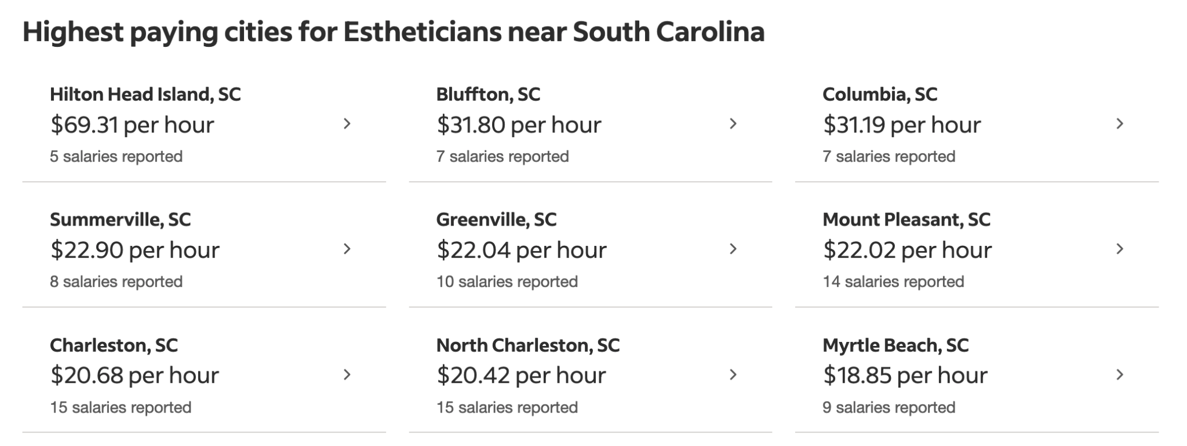
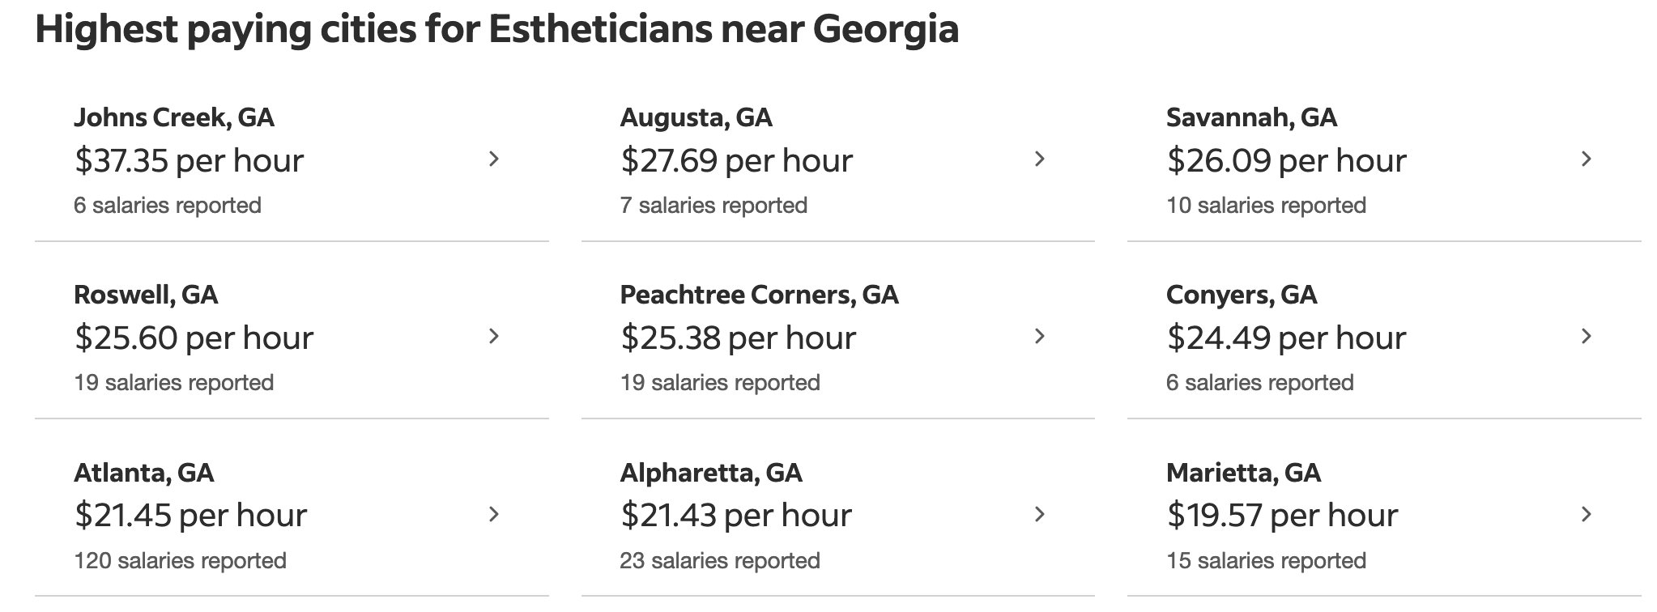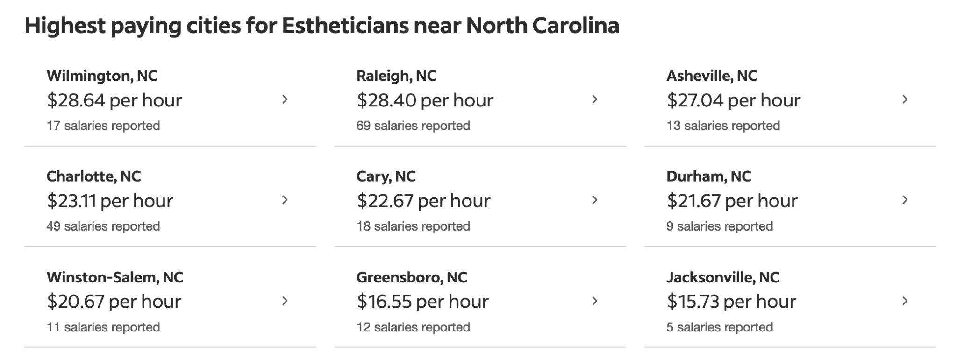
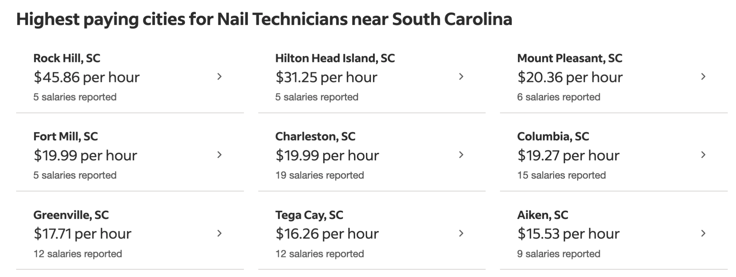
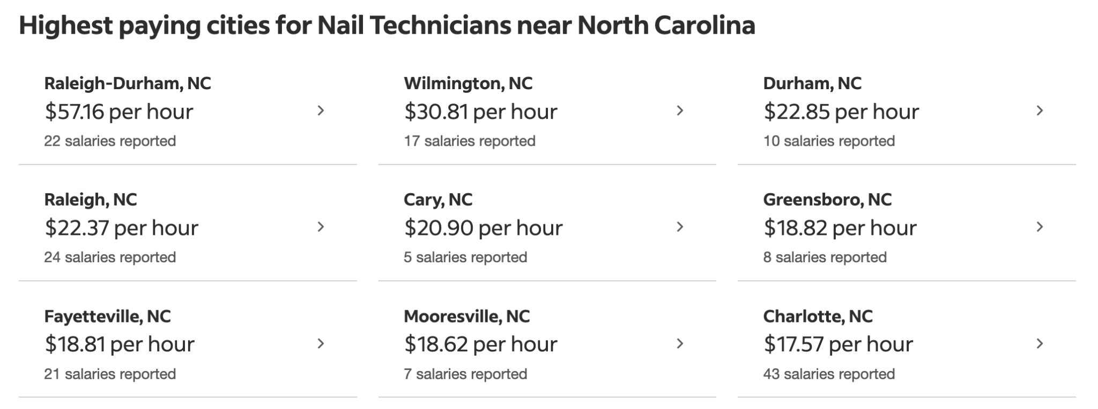
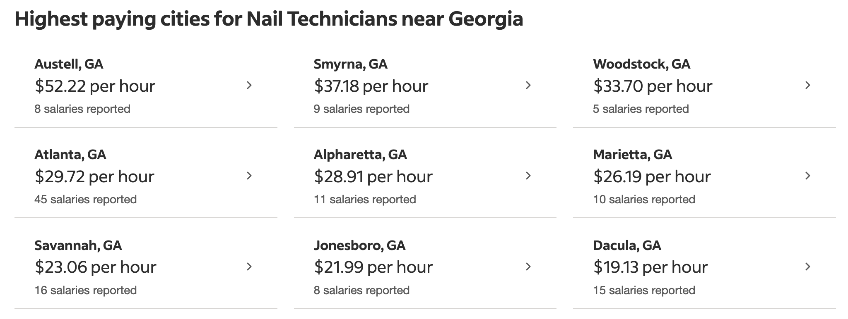
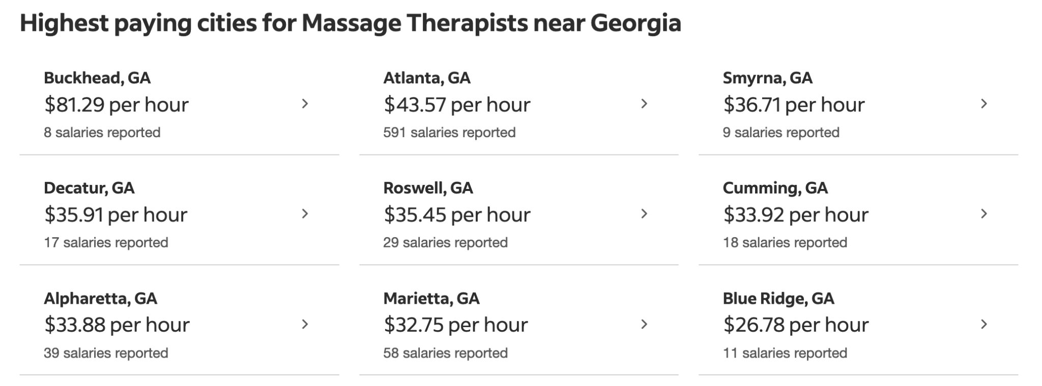
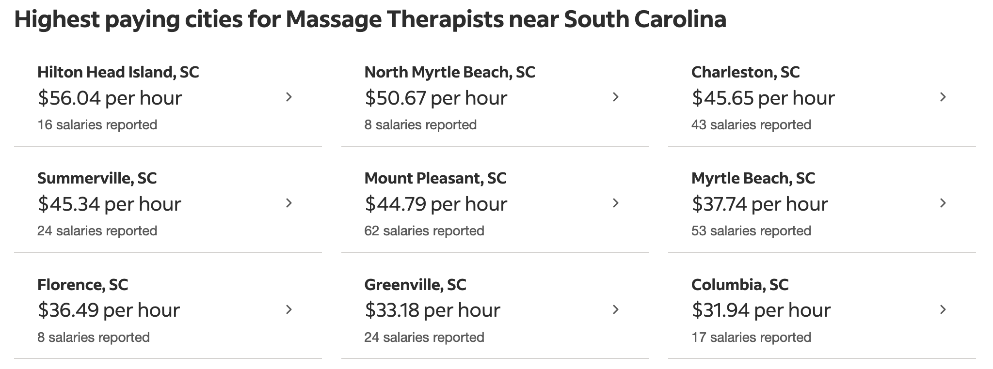
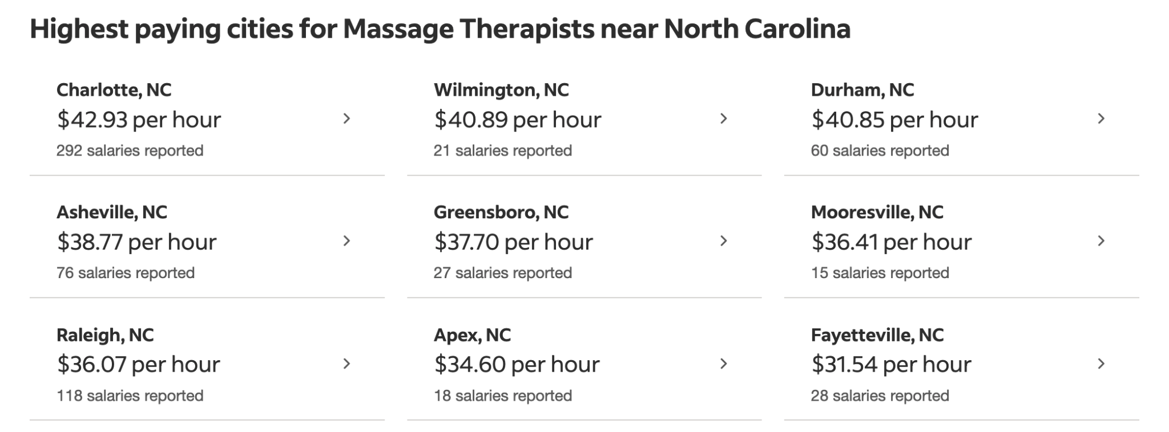

OFF-CAMPUS EVENTS & TRAINING

Occasionally, students will be required to attend off-campus events, facility tours, trainings, seminars, or shadow days. SEEI, its proprietors, officers, agents or any of its operators are not responsible for lost items, personal injury, or damages that arise from such activities. All policies of SEEI are applicable to off-site events. Students will only obtain hours for off-site events when they are accompanied by a Licensed Esthetics Instructor - specifically, an instructor overseeing their instruction at Southeastern Esthetics Institute.

RULES & REGULATIONS FOR CONDUCT
Southeastern Esthetics Institute requires all students enrolled in any programs to conduct themselves with the highest regard of professionalism. Respect for fellow students, instructors, and administrators is paramount. Students must display a positive attitude in all classroom activities and settings within the facility. Any behavior that counteracts these policies is subject to review. Southeastern Esthetics Institute holds the right to terminate a student through a formal expulsion if the institution finds the student to be in violation of any of the following:

- Cheating, plagiarism, or other forms of academic dishonesty
- Providing false information to any institutional official or faculty member
- Infringements of the Social Media Policy
- Forgery, alteration or misuse of any documents or records
- Disruptive activity that causes the obstruction of teaching, learning, research, administration, conduct, or infringement upon the rights of others
- Failure to comply with the directions and regulations of the institution under the SC LLR Board of Cosmetology rules and regulations
- Drug use of any kind and/or smoking in or around the institution; This includes the use of vaping pens.
- Theft of any kind, including seizing, receiving, or concealing property with knowledge that it has been stolen
- Damage to, or destruction of, property or actions that have the potential for such damage or destruction
- Actions which result in physical harm, have the potential for physical harming of another person, which creates conditions that pose a risk of physical harm
- Harassment: Conduct that creates or attempts to create an intimidating, hostile, or offensive environment for another person
- The use of weapons, firearms, or explosives - or the use or display of any object deemed dangerous by the administration
- Sexual Harassment: Unwelcome verbal or physical conduct that is considered pervasive and objectively offensive by instructional administration
- Children are not allowed on campus with SEEI students during class time, unless otherwise approved as a model opportunity for laboratory completions.

Disciplinary Action
Southeastern Esthetics Institute upholds the right to suspend a student, temporarily or permanently, through an official Expulsion Ruling. Expulsion Ruling documents are detailed as to the matters that led up to the expulsion decision and are recorded on the student’s academic record. The document is then notarized by a certified official and delivered to the student. Students are not allowed on the premises after a suspension or expulsion - and any trespassing after a suspension documentation or Expulsion Ruling has been delivered is not permitted.

Termination Policy
Southeastern Esthetics Institute upholds the right to suspend a student, temporarily or permanently, through an official Expulsion Ruling. Expulsion Ruling documents are detailed as to the matters that led up to the expulsion decision are recorded on the student’s academic record. The document is then notarized by a certified official and delivered to the student. Students are not allowed on the premises after a suspension or expulsion - and any trespassing after a suspension documentation or Expulsion Ruling has been delivered is not permitted.

STUDENT RECORDS & SAFE-GUARDING POLICY

Southeastern Esthetics Institute maintains proper accounting & data collections software within its administrative office to accurately store student information pertaining to their tenure as a student, along with all financing information and personal data. This information is cloud- based - and as such is therefore fireproof in nature. Student identity is extremely important to SEEI - and is verified through the collection of a student’s social security number, in addition to two forms of government-issued identification.

ADVISING & PROFESSIONAL ASSISTANCE

SEEI students are encouraged to talk to Administrators and Instructors whenever problems arise in personal or school life. When students need counseling that is not available in-house, a contact list of local professionals is given to the student to call for assistance. If professional assistance is necessary, SEEI will maintain a record of this referral. SEEI staff members have been instructed that if a student should require, either by request or instructor observation, professional assistance, the following resources are available:
Domestic Violence Information 800-897-5465
National Sexual Assault Hotline 800-656-HOPE
National Suicide Prevention Lifeline 800-273-8255

Student Grievance Policy

Should students have a formal complaint, the student must fill out a formal Grievance & Student Complaint Document within the administrative office of Southeastern Esthetics Institute. The institution promises to provide exceptional feedback and support when dealing with student grievances. Students should expect to receive a written formal reply, with enclosed methods and standards of resolution of complaint, within ten (10) business days of the initial complaint. Any grievances of students that have not been properly dealt with through the administrative team are welcome to send all grievances and responses to the Council on Occupational Education at 78840 Roswell Road, Building 300, Suite 325, Atlanta, Georgia 30350. Students may additionally contact by phone at 1-800-917-2081. www.council.org
South Carolina Board of Cosmetology - How to File a Complaint
A complaint against a licensee, or an unlicensed person practicing a profession or occupation that requires a license, may be made via the link provided here >> https://eservice.llr.sc.gov/Complaints/
The form may be obtained by utilizing the link above or by calling (803) 896-4470. The complaining party is responsible for ensuring that all necessary information is included on the form. In completing the form, you are referred to as the complainant. The individual or business you are filing a complaint against is referred to as the respondent. Please state all facts briefly and clearly. Also, include the name, address and phone number of all witnesses, and the specific information they possess to substantiate the complaint. Please include copies of any documents, records, statements or contracts that may assist this agency to conduct an inquiry. Upon completion, simply click on "submit" to file the complaint with the agency. Upon receipt of the complaint and jurisdiction is established, a thorough investigation is conducted to determine whether a violation has occurred. If a violation of the practice act is found, the respondent may be offered a consent agreement, or a hearing may be held before the appropriate Board or Commission to resolve the findings of the agency's investigation. Although this action is between the State and the Respondent, the complainant should be prepared to testify, as requested, at a hearing before the Board or Commission if the matter has not been otherwise resolved. The complaint will be dismissed by the Board or Commission if a violation is not found or the case does not present evidence that would sustain a legal procedure.

South Carolina Commission on Higher Education How to File a Complaint

Any person having a complaint or grievance against an institution that is licensed by the Commission should make a reasonable effort to obtain satisfaction from the institution directly through the institution's established procedures. In the event that a solution cannot be reached, the person may file a written complaint with the Commission. The complaint should include any evidence bearing on the issues and documentation that a reasonable effort was made to resolve the complaint directly with the institution.

The Commission will review the facts as set forth in the complaint and may intervene, as appropriate, to bring the matter to a satisfactory conclusion. Such intervention shall be limited to facilitating settlement through negotiation, and shall not include legal action for any party. Notwithstanding the refund policy of the institution, if the Commission determines that the circumstances justify such action, it may require that the institution make a full or partial refund of tuition or other fees as appropriate. If, in the opinion of the Commission, there is evidence that the institution may no longer be maintaining minimum standards, the Commission may call for an investigation to determine whether the institution's license should be revoked.

Notwithstanding an exemption from the oversight of the Commission, the Commission may intervene on the behalf of a person filing a complaint against an institution that is exempt from the oversight of the Commission. If merited and in the interest of consumer protection and in the absence of other means by which a person may have access to an oversight entity through which he or she may obtain assistance, the Commission may intervene. In its efforts to mediate an issue,
the Commission may, through its complaint procedure, investigate an institution and encourage officials of an institution to make reasonable efforts to resolve the complaint in a fair and equitable manner.

VOTER REGISTRATION

The school encourages its students to be registered voters and to exercise their right to vote. Students can complete a Voter Registration Form online by visiting https://info.scvotes.sc.gov/eng/ovr/start.aspx

CONTINUING EDUCATION

All persons licensed by the South Carolina LLR Board of Cosmetology must show satisfactory evidence of 4 contact hours in Infection Control biennially.

Continuing Education Providers can be found within the following link to the LLR website: https://www.llr.sc.gov/cosmo/ce.aspx

STUDENT SPA CLINIC
As per the SC LLR Board of Cosmetology standards, Esthetics students must complete approximately 60 hours of instruction prior to practicing/working on members of the public.

ELITE SPA SCHEDULE:
Daytime Esthetics: Monday-Friday 9:00am-3:00pm
Evening Esthetics: Monday-Thursday 4:00pm-9:00pm

Hours are subject to change.

Spa Scheduling Requirements

Students must set up for their first appointment no less than 30 minutes prior to the beginning of the clinic day. Students are mutually responsible for working together to prepare towels, launder linens, and prepare treatment tables and implements. Students will receive their SPA SCHEDULE from the Clinic Leader on duty and will work with their ROOM TEAMS to disseminate clients fairly and equally. Students are encouraged to work together with their teams to achieve client satisfaction and clinic success!

Rules of the Spa

In order to maintain a professional standard in the Elite Spa, the following standards will be observed:

- Any student who is disrespectful or abusive to a client will be subject to disciplinary action
- Students are required to complete all services for which they are scheduled
- Students are responsible for ensuring a clean and stocked treatment area
- Students are responsible for acquiring supplies from the dispensary, unless there is a designated student on dispensary duty
- Students must maintain a quiet voice while working in the spa clinic setting
- Students may not congregate at the reception desk while waiting for the next client - or lounging in and/or around the seating area
- Students may not remove supplies or rearrange cupboards or drawers without direct supervision and authority by an Instructor or Clinic Leader
- All clients must be checked out by the Customer Care Specialist on duty
- Students must clean and restock room/clinic floor to “tour-ready” conditions immediately after services have been rendered
- Students are required to handle and implement all cleaning, mopping, laundering, disinfection, and sanitation required in and around the school at the end of each school day - with a positive attitude.
- Cleaning duties are dispersed in a fair manner between all students by Instructors or Clinic Leaders on staff - and will be charted accordingly.

DRESS CODE

It is required that students wear proper attire for all classroom and/or clinic work in the school setting at all times.
Esthetics students are required to wear black scrub clothing (no leggings) and comfortable, close-toed shoes during all classroom activity. Students are always required to wear a Student Name Tag daily.
Cosmetology students are required to wear pewter scrub clothing (no leggings) and comfortable, close-toed shoes during all classroom activity. Students are always required to wear a Student Name Tag daily.
Nail Technology students are required to wear carribean blue scrub clothing (no leggings) and comfortable, close-toed shoes during all classroom activity. Students are always required to wear a Student Name Tag daily.
Massage Therapy students are required to wear royal blue scrub clothing (no leggings) and comfortable, close-toed shoes during all classroom activity. Students are always required to wear a Student Name Tag daily.
Advanced Esthetics Academy students are required to wear turquoise blue scrub clothing (no leggings) and comfortable, close-toed shoes during all classroom activity. Students are always required to wear a Student Name Tag daily.
Hair and makeup are also required to be in good taste, along with minimal jewelry. Students must wear their nails short and well-manicured. If students fail to comply with the dress code listed, students may be sent home with loss of hours for that class day. STUDENTS MUST WEAR NAILS SHORT TO CLASS AT ALL TIMES.
- SEEI approved scrub tops, bottoms & Student Name Tag with appropriate lanyard per class group must be worn at all times.
- Solid black long-sleeve shirts may be worn underneath scrub tops. No hoodies, turtlenecks, printed shirts, ruffled shirts, textured or “thermal” material shirts may be worn under scrub tops.
- White, black or gray colored socks and shoes are allowed. Open toed shoes, boots, or high-heeled shoes are not allowed.
- Bandanas, beanies, or hats are not allowed. Only black, white or gray headbands with no embellishments are allowed.
- Only approved SEEI black jackets, hoodies, or lab coats may be worn on campus.

SAFETY HAZARDS & PHYSICAL DEMANDS

Keep in mind that there are physical demands associated with the profession that each prospective student must be aware of before enrolling. By following safety precautions and proper ergonomics, you can contribute to the health, welfare, and safety of clients and employees in the workplace. The school provides First Aid Kits, sharps containers, proper cleaning & disinfection products, UV sanitizers for all implements, hand sanitizing units in all bathrooms, dispensary, and clinic areas; as well as quaternary ammonium compounds solutions for metal implements. Southeastern Esthetics Institute complies with all safety & infection control regulations put into place by the SC LLR Board of Cosmetology. All safety & infection control guidelines are posted daily on the Dispensary Bulletin Board & students will sign and date during each new enrollment period.

Southeastern Esthetics Institute reserves the right to call 911 in the case of any student medical emergency immediately through the list below. Emergency contacts will be called secondary within the student file. In the event of a student health emergency, students will be cleared from the classroom and SEEI staff are required to follow specific protocols pertaining to notifying medical personnel.

Some examples of 911 for medical emergencies include, but are not limited to:
• Severe allergic reaction
• Choking or severe difficulty breathing
• Shock
• Deep wound or part of the body that was crushed
• Bleeding that is difficult to control
• Back and neck injuries or broken bones
• Severe head injury
• Unconsciousness
• Seizures
• Serious burns
• Spill or release of hazardous chemicals

OSHA Requirements

In compliance with the US Department of Labor: Occupational Safety & Health Administration requirements, the school advises its students of the chemicals used in cosmetology/related training. During the course work, the students learn about the importance of safety in the workplace and how to use and follow the Material Safety Data Sheets (SDS) for chemicals used in cosmetology or related training. During each unit of study, students are apprised of the various chemicals used and safe practices that apply. A complete file containing SDS for the chemicals used is available in the Dispensary. The school endeavors to facilitate a safe environment for all staff and students by teaching proper usage of equipment, tools, and products. The school does not assume responsibility for injuries resulting from improper or unsafe use of equipment, tools, and products.

Evacuation Plan

- All occupants should proceed to the nearest available exit in an orderly, calm manner
- Leave all personal belongings behind
- Assist the elderly, handicapped, and children to the nearest exit
- Do not attempt to contain the fire; Evacuate immediately and leave containment to the trained professionals
- Once safely outside, meet in the parking lot to ensure safety for group
- Instructors will take a headcount to ensure no one is still inside
- The Administrator will call the fire officials or delegate it to one person
- Stay calm and help calm others
- The school is a non-smoking facility
- Students at no time should have an open flame within or near the school premises

CAMPUS PARKING
Surface parking is free and available at the 501 Spears Creek Church Road campus, located on our 29.16 acre property. Students are required to park on the left side of the parking lot as students are entering from the Main Entrance daily.

COMPLETION, LICENSURE & PLACEMENT RATES

We are honored to showcase our ANNUAL REPORT for the Council on Occupational Education for the academic year of July 1, 2021-June 30, 2022, as due on March 15, 2023. We’ve truly enjoyed connecting with our graduates to find out their licensure and placement information to report to YOU!

Our Completion, Licensure, and Placement reporting is as follows. Please note that the COE benchmark requirements are: Completion 60%, Placement 70%, and Licensure 70%. Therefore, we are honored to showcase our outcomes for this academic year as being HIGHER than required! Congratulations to our graduates!

Esthetics Licensure Course
Completion 89%
Placement 88%
Licensure 100%

Advanced Esthetics Academy
Completion 93%
Placement 85%
Licensure 100%

Retention Rate

Southeastern Esthetics Institute complies with the Retention Rate reporting that must be readily available to current and prospective students.

Undergraduate Retention and Graduation Rate Cohort

First-time, full-time student retention rate N/A

First-time, part-time retention rate N/A

Graduation rate cohort as percent of total students entering N/A

CAMPUS CRIME & SAFETY POLICY

Any emergencies or criminal actions should be immediately reported to the Chief Administrative Officer, Administrator and/or the local law enforcement authorities. The school staff must be notified in addition to the law enforcement agency. To ensure prompt and accurate record keeping, criminal activity should be documented in a timely manner by students and/ or employees. The school is not liable for any crime that occurs on campus, but it is required to report criminal activity. In order to do this, it is necessary to obtain documentation for any incident. SEEI promotes safety and it recommends that students, staff, and faculty use precautionary measures. If you are concerned for the safety of your belongings, we recommend that you either do not bring them to school or that you obtain a renter’s insurance policy or homeowner’s insurance policy to cover your personal property while in school.
A copy of the Annual Crime Statistics can be found within the CRIME LOG within the Chief Administrative Officer office at 501 Spears Creek Church Road campus in Elgin, South Carolina.
Southeastern Esthetics Institute complies with Federal Student Aid standards regarding publicly posting the required Security & Fire Safety Report. Students may locate this on the institutional website through the link here:
https://www.seestheticsinstitute.com/uploads/8/5/9/7/85970698/security_report___fire_safety_report__1_.pdf
Southeastern Esthetics Institute a notice by October 1 annually and will provide a paper copy upon request.

TUITION FUNDING OPPORTUNITIES

In addition to Federal Financial Aid through the U.S. Department of Education, Southeastern Esthetics Institute accepts cash, checks, money orders, and credit cards as payment for tuition, books, and supplies. Southeastern Esthetics Institute currently accepts funding for all validated parties through the United States Department of Veterans Affairs.
If you feel you are eligible for benefits from the United States Department of Veterans Affairs, please visit the website link below. http://benefits.va.gov/gibill/

WITHDRAWAL POLICY

Southeastern Esthetics Institute withholds the right to apply a $100 Withdrawal Fee to all students opting to withdraw from the Esthetics Licensure Course. This fee will be applied to the original invoice as a service provided to administer the proper paperwork involved to disenroll a student from our institution.

Federal Student Aid: Guidelines & Policies
Congress | The Department of Education | Schools | Students & Their Families | Students
Responsible for writing the law and allocating funding for the programs | Responsible for approving schools to participate,  delivering funds to  the schools, writing  regulations based on law, and  monitoring  compliance with laws and regulations. | Responsible for providing quality  education and properly  administering the  federal student aid (FSA) programs. | Primarily responsible for  funding the student’s  postsecondary education. | Responsible for successfully  completing their education and repaying their loans.

FAFSA
Completing the Free Application for Federal Student Aid (FAFSA form) is the first step toward receiving Title IV aid. The information provided by the student (and for dependent students, the parents) assists the U.S. Department of Education in determining a student’s eligibility for federal student aid. The information from the FAFSA form is sent to student-selected schools in an electronic format called an Institutional Student Information Record, an ISIR. Students will receive a report called a Student Aid Report, a SAR.

Federal Return of Title IV Funds Policy
Southeastern Esthetics Institute participates in Federal Financial Aid. Please refer to the following refund policy for specific consumer information pursuant to the federal financial aid program. Title IV federal financial aid funds are awarded under the assumption that a student will remain in classroom attendance for the entire period for which funds were awarded. If a financial aid recipient withdraws from school after beginning attendance, the amount of Title IV grant or loan assistance earned by the student must be determined. The school is required to calculate the amount of Federal Title IV funds to be returned for a student who has withdrawn from all classes. For students who have received Title IV financial assistance, the Federal Return of Title IV Funds calculation will be completed first and applicable funds returned. Returned funds will be reduced from the payments received on behalf of the student before applying the institutional refund policy to determine whether the student is owed a refund or if a balance is owed to the institution. If a student has received less aid than that student earned, he/she may be eligible for a post-withdrawal disbursement. If a student is eligible for this disbursement, the school will notify the student in writing of the amount for which he/she is eligible. The student will have 14 days to accept or decline the disbursement. If an acceptance is not received within this time frame, the institution will not make the post-withdrawal disbursement to the student. The Federal Return of Title IV Funds formula dictates the amount of federal Title IV aid that must be returned to the federal government when that student withdraws on or before the 60 percent point in time in the payment period. The federal formula requires a return of Title IV aid if the student received federal financial assistance in the form of Stafford Loans, Pell Grants, or PLUS Loans and withdrawals on or before completing 60 percent of the payment period. The percentage of Title IV aid earned is equal to the percentage of the payment period that was completed as of the withdrawal date if this occurs on or before the 60 percent point of time. The percentage that has not been earned is calculated by determining the complement of the percentage earned (e.g., if 40 percent was earned, 60 percent was unearned). The amount to be returned is calculated by subtracting the amount of Title IV assistance earned from the amount of Title IV aid that was or could have been disbursed as of the withdrawal date. The percentage of the payment period scheduled to complete is calculated by dividing the total number of clock hours scheduled to complete by the payment period as of the last date of attendance. If a student unofficially or officially withdraws and has received federal loans, the loans will go into repayment once the grace period expires: a. Unofficial withdrawal applies when a student is absent for 14 or more consecutive calendar days; b. Official withdrawal applies when a student notifies the school in writing or in person. In both cases the last day of attendance will be used in the return to Title IV calculation. School scheduled breaks of five (5) or more consecutive days are excluded from the return to title IV calculation as periods of nonattendance and, therefore, do not affect the calculation of the amount of federal student aid earned. This provides for more equitable treatment of students who officially or unofficially withdraw near either end of the schedule break. Title IV funds will be returned to the United States Department of Education within 45 days. NOTE: A student who withdraws prior to completing 60 percent of the charging period may be required to repay some of the funds released to the student because of a credit balance on the student’s account.
Refunds to Title IV programs will be made in the following order:
Federal Unsubsidized Stafford Loan | Federal Subsidized Stafford Loan | Federal PLUS Loan | Federal Pell Grant

Student Financial Aid Release
The undersigned agrees that Southeastern Esthetics Institute does not guarantee the student loan process in any respect. A Federal Parent Plus loan requires a credit check and is based on the parent’s credit. Pre-approval for a Parent Plus loan does not guarantee that the parent will receive a Federal Parent Plus loan. It is critical that the parent be able to pass a credit check when the loan is certified. The school has no control over the approval or decline of a parent’s credit history. Nor does the school assume any responsibility for mistakes on any Department of Education financial aid forms. It is up to the student to make sure all forms are accurate and complete.
Federal loan information is available in the National Student Loan Database System (NSLDS) and will be accessible by Servicers and Schools, as authorized.

Verification of Title IV Funding
The school has policies and procedures that it follows for verification of Title IV funding. Verification is a requirement by the U.S. Department of Education. Students are randomly selected to provide additional information. The school provides students with a verification form so they can collect the necessary information. The school gives the student a 30-day deadline to return the form to the financial office with verification items attached. If verification documents are not submitted by the due date, the student will be placed on a monthly cash pay status until verification is completed. The corporate office sends to the school a change in EFC form for students to sign if their EFC changes. SMART handles our student overpayments and alerts the school so it can make changes to the award packet, which is reported to Common Origination and Disbursement (COD) for the Department of Education.

Eligibility of Financial Aid After a Drug Conviction
Students will be given written notice advising them that a conviction of illegal drugs, of any offense, during an enrollment period for which the student was receiving Title IV financial aid will result in the loss of eligibility for any Title IV per HEA Sec. 484(r)(1) and 20 U.S.C. 1091(r)(1).Students whose eligibility has been suspended due to a drug conviction may resume eligibility if they successfully pass two (2) unannounced drug tests conducted by a drug rehabilitation program that complies with criteria established under HEA Sec. 484(r)(2) (20 U.S.C. 1091(r)(2)).

REFUND POLICY

1. Refunds for Classes Canceled by the Institution
a. If tuition and fees are collected in advance of the start date of a program and the institution cancels the class, the institution refunds 100% of the tuition and fees collected.
b. The institution makes these refunds within 45 days of the planned start date.
2. Refunds for Students Who Withdraw on or Before the First Day of Class
a. If tuition and fees are collected in advance of the start date of classes and the student does not begin classes or withdraws on the first day of classes, the institution retains no more than $100 of the tuition and fees.
b. Appropriate refunds for a student who does not begin classes are made within 45 days of the class start date.
3. Refunds for Students Enrolled Prior to Visiting the Institution
a. Students who have not visited the school facility prior to enrollment have the opportunity to withdraw without penalty within three days following either attendance at a regularly-scheduled orientation or following a tour of the facilities and inspection of the equipment.
4. Refunds for Students Enrolled in Professional Development, Continuing Education, or Limited Contract Instruction
a. The institution will either credit the student towards another course date if the student decides to withdraw prior to the course date - or the student can obtain a 100% refund of the tuition/costs of the course.
5. Refunds for Withdrawal After Class Commences
a. During the first 10% of the period of financial obligation, the institution refunds at least 90% of the tuition;
b. After the first 25% of the period of financial obligation and until the end of the first 50% of the period of obligation, the institution refunds at least 25% of the tuition; and,
c. After the first 50% of the period of financial obligation, the institution may retain all of the tuition.

CREDIT BALANCE POLICY

If students have an outstanding credit balance with Southeastern Esthetics Institute, the institution must issue any credit balance to the student within fourteen (14) days. Southeastern Esthetics Institute allows students to hold the credit balance for future charges at the institution and can additionally request for the hold to be released at any time.

SPECIAL PROVISION FOR BOOKS AND SUPPLIES

In order to academically succeed in a program, a Federal Pell Grant student must have the ability to purchase books and supplies at the beginning of the academic period. By the seventh day of a payment period, the school will provide a way for a student who is eligible for a Federal Pell Grant to obtain or purchase the books and supplies required for the payment period if:
Ten days before the beginning of the payment period, the school could have disbursed FSA funds to the student; and | Disbursement of those funds would have created an FSA credit balance. | The school will consider all FSA funds a student is eligible to receive at the time it makes the determination, but the school need not consider aid from non-FSA sources. | The amount the school. must provide is the lesser of the presumed credit balance or the amount determined by the school that the student needs to obtain the books and supplies.
In determining the required amount, the school may use the actual cost of books and supplies, | or the allowance for those materials used in estimating the student’s cost of attendance for the period. | A student may decline to participate in the process to obtain or purchase books and supplies, if they so choose.

SATISFACTORY ACADEMIC PROGRESS (SAP)

Students enrolled in programs approved by COE must meet formal standards that measure their satisfactory progress towards graduation. The Satisfactory Academic Progress Policy is provided to all students prior to enrollment. The policy is consistently applied to all applicable students. Evaluations are maintained in the student file. The school will develop an academic and/or attendance plan to address the specific needs of those students who fail to meet the academic and/or attendance requirements at specific SAP evaluation points. A leave of absence will extend the student’s contract period and maximum time frame by the same number of days taken in the leave of absence. Students receive mandatory progress reports at the ten-week mark for Daytime Esthetics and the fifteen-week mark for Evening Esthetics during the Esthetics Licensure Course. All data collected and reviewed by faculty and student in question are then kept in hard copy format within the official student file.

Southeastern Esthetics Institute maintains the following rulings, regarding SAP Guidelines through the U.S. Department of Education:
● If a student at SEEI does not receive Title IV Funding, students are individually responsible for all financial obligations remaining at SEEI prior to receiving Exit Paperwork and Transcripts from all programs.
● Students at SEEI that post an appeal that is not approved will not be able to complete programs at SEEI and will be withdrawn.
● Students at SEEI that choose not to appeal will not be able to complete programs at SEEI and will be withdrawn.

Quantitative & Qualitative Factors

Factors for measuring the student’s progress towards satisfactory completion of the program include maintaining the following requirements:
- Students are assigned academic learning units and a minimum number of practical experiences for course completion.
- Academic learning is evaluated after each unit of study. Practical skills learning is evaluated as completed and counted toward course completion only when rated as satisfactory or better.
- Practical skills are evaluated according to test procedures as set forth in the practical skills competency criteria.
- Students must maintain a written grade average of 80 percent or higher.
- A minimum cumulative attendance of 80% of their scheduled hours.
- A student who has not achieved the minimum cumulative GPA of 80% and/or who has not successfully completed at least a cumulative rate of attendance of 80% is not eligible for Title IV assistance, if applicable, unless the student is on warning or has prevailed upon appeal of the determination that has resulted in the status of probation.

Warning

Students failing to meet minimum requirements for attendance and/or academic progress will be placed on Financial Aid Warning and considered to be making satisfactory academic progress during the warning period which is until the next evaluation period. The student will be advised in writing on the actions required to attain satisfactory academic progress. During the Financial Aid Warning period, students are eligible, if applicable, to receive financial aid funds. If at the end of the warning period, the student has still not met both academic and/or attendance requirements, he/she may be placed on probation and, if applicable, the student may be deemed ineligible to receive Title IV funds.

Appeal Procedure
A student may appeal the Financial Aid ineligible decision if he/she has a reason for not making satisfactory progress and if he/she can document that the circumstances that caused the unsatisfactory academic progress determination have in some way changed and that satisfactory academic progress standard can be met by the end of the evaluation period. A student has five (5) calendar days from the date of notification to appeal that they are not meeting the satisfactory progress requirements. The student must submit a written appeal to the school’s financial aid office on the designated schools Appeal Form describing why they failed to meet satisfactory academic progress standards, along with supporting documentation of the reasons why the determination should be reversed. This information should include what has changed about the student’s situation that will allow them to achieve satisfactory academic progress. The reasons for which a student may appeal a negative progress determination include death of a relative, an injury or illness of the student, a student’s disability, or any other allowable special or mitigating circumstances. The Appeal documents will be reviewed and a decision will be made and reported to the student within 5-7 calendar days. The appeal and decision documents will be retained in the student’s file. If the student prevails upon appeal, the satisfactory academic progress determination will be reversed and federal financial aid will be reinstated, if applicable. If the appeal is granted the student will be placed on Financial Aid Probation for one evaluation period. If the student has not met academic and/or attendance requirements after the one evaluation period, and does not prevail on appeal, the student will be determined as not making satisfactory progress and may be terminated. This policy applies to all students regardless of whether or not they are eligible for Title IV funding programs. In order to comply with the United States Department of Education requirements the terminology financial aid warning or financial aid probation will be used for both Title IV and non-Title IV students.

Probation
Students who fail to meet the minimum requirements for attendance and academic progress after the warning period will be placed on probation. If the student appeals the decision and prevails upon the appeal, the student will be considered to be making satisfactory academic progress while during the probationary period of 5-7 calendar days and Financial Aid will be reinstated.
Additionally, only students who have the ability to meet satisfactory academic progress policy standards by the end of the evaluation period may be placed on probation. Students must be able to meet requirements set forth by the end of the evaluation period of 5-7 calendar days. Students who are progressing will be considered making satisfactory academic progress. The student will be advised in writing of the actions required to attain satisfactory academic progress. If at the end of the probationary period, the student has still not met both the attendance and academic requirements required for satisfactory academic progress, the student will be determined as NOT making satisfactory academic progress, and the student will not be deemed eligible to receive Title IV funds.

Termination Appeal Procedure
If a student is terminated due to receiving the maximum amount of coaching sessions, or due to the reasons outlined under termination on the Student Advisory Form, the student may appeal the termination decision. A student has five (5) calendar days from the date of termination to appeal the decision. The student must submit a written appeal to the school’s Financial Aid Officer on the schools Termination Appeal Form describing why they were terminated, along with supporting documentation of the reasons why the determination should be reversed. This information should include what has changed about the student’s situation that will allow them to continue through the program without incident. An appeal hearing will take place within 5-7 business days of receipt of the written appeal. This hearing will be attended by the student, parent/guardian (if the student is a dependent minor), Financial Aid Officer, Institutional Advisory Committee (at least one member), and the Chief Administrative Officer. A decision on the student’s appeal will be made within three (3) business days by the Chief Administrative Officer and will be communicated to the student in writing. This decision will be final.

Reestablishing SAP
Students may re-establish satisfactory academic progress and Title IV funding, as applicable, by meeting the minimum attendance and academic requirements by the end of the warning or probationary period.

Reinstatement of Financial Aid
If applicable, Title IV financial aid will be reinstated to qualified students who have prevailed upon appeal or who have reestablished satisfactory progress by meeting the minimum cumulative attendance and academic requirements.
STUDENTS RE-ENROLLING INTO THE PROGRAM AFTER A WITHDRAWAL
Students choosing to re-enroll into the Esthetics Licensure Course at Southeastern Esthetics Institute may only restart on a new start date. The student will be placed on the class roster for this start date.
The Chief Administrative Officer will discuss placement into other classrooms after the first week of re-enrollment.
Students returning within 180 days after Withdrawal:
  - Financial Aid is reinstated; Out of pocket expenses remain the same.
  - If a student does not have a previous Student Kit item, they must pay out of pocket to replace the updated and complete Student Kit.
Students returning 180 days after Withdrawal:
  - Students are considered transfer students and their Financial Aid award will change.
  - Students will be automatically recharged for the Student Kit Fee.
  - Students are not allowed to start until new Financial Aid is awarded and students have signed a new award letter and credit card authorization agreement.

COMPLETION OF COURSE WITHIN DESIGNATED PERIOD OF TIME

Southeastern Esthetics Institute - Esthetics Licensure Course DAYTIME: Full-Time Students attend five (5) days (Monday-Friday), 30 hours per week, from 9:00am-3:00pm. Esthetics Licensure Course EVENING: Full-Time Students attend four (4) days (Monday-Thursday), 20 hours per week, from 4:00pm-9:00pm.
The ESTHETICS LICENSURE COURSE at Southeastern Esthetics Institute is 600 clock hours, as approved by the South Carolina LLR Board of Cosmetology. Students are expected to complete the course in no more than 125% of the program length. If a student is never absent, he/she should complete the course within 20 weeks for a full-time daytime student and within 30 weeks for a full-time evening student. Students at Southeastern Esthetics Institute are required to pay per clock hours if exceeding the Maximum Time Frame at $31.66 per hour.

MAXIMUM TIME FRAME
Students must complete the educational program within the maximum time frame, which is based on attending at least 80% of the scheduled hours.

COURSE | LENGTH | MAXIMUM TIME FRAME
ESTHETICS LICENSURE COURSE - DAYTIME | 20 WEEKS | 25 WEEKS
ESTHETICS LICENSURE COURSE - EVENING | 30 WEEKS | 37.5 WEEKS
ADVANCED ESTHETICS ACADEMY | 13 WEEKS | 15.5 WEEKS
COSMETOLOGY PROGRAM | 50 WEEKS | 62.5 WEEKS
NAIL TECHNOLOGY PROGRAM | 10 WEEKS | 12.5 WEEKS
MASSAGE PROGRAM | 22 WEEKS | 27.5 WEEKS

Interruptions, Course Incompletes, and Withdrawals

If the student needs to take off more time than allotted in the contract or more than 14 consecutive calendar days, he/she must take a leave of absence or withdraw and re-enroll when ready to return. If a student needs more than 14 consecutive calendar days of time off due to pregnancy/new mother, and/or military duty then the student should take a leave of absence. Students who withdraw prior to completing the course of study and who wish to reenter will reenter at the same progress status as applicable at the time of withdrawal.
SEEI withholds the right to charge a withdrawal fee of $100 for all students withdrawing at any point in time from Southeastern Esthetics Institute.
Students that discontinue attendance and do not come within two weeks to sign required withdrawal paperwork from our programs will automatically be withdrawn at the two-week point and use this date as the “end date” of their time at Southeastern Esthetics Institute. This will be documented for the student record.

LEAVE OF ABSENCE POLICY
A Leave of Absence (LOA) is a temporary interruption in a student’s program of study. LOA refers to the specific time period during an ongoing program when a student is not in academic attendance. Leaves of Absence will be granted in the case of pregnancy or new mothers. A leave of absence will be permitted with a letter from the student’s doctor. If a student is called into active duty for the military the school will grant a leave of absence. Students may also be granted a leave of absence for bereavement/death of a friend or family member. These are the only times leave of absences are granted.
A leave of absence will extend the student’s contract period and maximum time frame by the same number of days taken in the leave of absence. In order to be placed on Leave of Absence, the student must:
- Complete and sign the school’s Leave of Absence Request Form
- Be approved by the SEEI Financial Aid Coordinator
- Must be in Satisfactory Progress
Leaves must be a minimum of FOUR DAYS and must not exceed a total of SIX MONTHS. Students may not arbitrarily decide to “take” a leave of absence. There will be no additional charges for a LOA. If the student fails to return or contact the School Financial Aid Leader on the documented return date, the Student will be considered to have withdrawn from school as of that date the student began the LOA. The withdrawal date for the purpose of calculating a refund is always the student’s last day of attendance. For federal aid recipients, the student’s payment period is suspended during the LOA and no federal financial aid will be disbursed to student while on a Leave of Absence. Upon the student’s return, the student will resume the same payment period and coursework and will not be eligible for additional Title IV aid until the payment period has been completed. If the student is a Title IV loan recipient, the student will be informed of the effects that the student’s failure to return from a leave may have on the student’s loan repayment terms, including the expiration of the student’s grace period. A contract addendum will be completed upon return from the LOA to extend the contract end date by the applicable number of days. In order to grant a Leave of Absence there must be the expectation that the student will be returning to school. A student who is granted a LOA that meets these criteria is not considered to have withdrawn and no refund calculation is required at that time. Changes to the contract period on the enrollment agreement must be initialed by all parties or an addendum must be signed and dated by all parties to reflect the new contract end date.

EVALUATION PROCEDURES & REQUIRED LEVEL OF ACHIEVEMENT

Students receive mandatory progress reports at the ten-week mark (halfway point) during the Esthetics Licensure Course. All data collected and reviewed by faculty and the student in question are then kept in hard copy format within the official student file. The following grading system is used to evaluate a student’s academic ability: Examinations are given in all subjects. Grades and attendance (Satisfactory Academic Progress) records are reviewed and signed by the student and maintained in the student’s financial file. The Satisfactory Academic Progress will reflect if the student evaluation will impact the students’ eligibility for Financial Aid The student may request to review their financial aid file from the Financial Officer. The following grading scale is used for theory progress: 93-100 (A); 85-92 (B), 74-84 (C); 0-74 (F) Practical and clinical work is graded by a signature and check mark on each clinical requirement listed on the student’s practical clinic worksheet. A signature from an instructor represents a passing grade which means all elements of the practical grading criteria were met. No signature indicates a failing score which means one or more of the practical grading criteria elements were not met and the student has not met minimum satisfactory standards on the practical application. Students are required to continue and/or repeat the practical application until they receive a signature from an instructor. Students must make up failed or missed tests and incomplete assignments.
Students must successfully complete the clock hours and weeks in each payment period before receiving a subsequent disbursement.

COPYRIGHT INFRINGEMENT POLICIES & SANCTIONS
Students are to be informed that unauthorized distribution of copyrighted material, including unauthorized peer-to-peer file sharing may subject them to civil and criminal liabilities. Southeastern Esthetics Institute maintains strict policies with respect to unauthorized peer-to-peer file sharing, including disciplinary actions taken against students who engage in illegal downloading or unauthorized distribution of copyrighted materials using the school’s information technology system. Southeastern Esthetics Institute withholds the right to press legal charges to the fullest extent if found guilty.
Copyright infringement is the act of violating any of a copyright owner’s exclusive rights granted by the federal Copyright Act. The legal penalties for copyright infringement are:
1. Infringer pays the actual dollar amount of damages and profits.
2. The law provides a range from $200 to $150,000 for each work infringed.
3. Infringer pays for all attorney’s fees and court costs.
4. The Court can issue an injunction to stop the infringing acts.
5. The Court can impound the illegal works.
6. The infringer can go to jail.

VACCINATION POLICY
Southeastern Esthetics Institute does not require specific vaccinations to attend any programs within its facilities.

STUDENT BODY DIVERSITY

Southeastern Esthetics Institute upholds all federal regulations regarding the requirement to make available to current and prospective students’ information about student body diversity, including the percentage of enrolled, full-time students in the following categories, per the following REPORTING PERIODS for IPEDS.
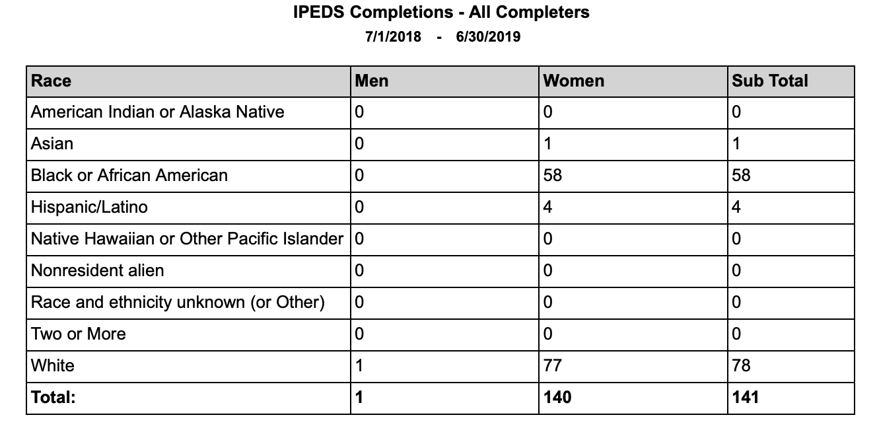
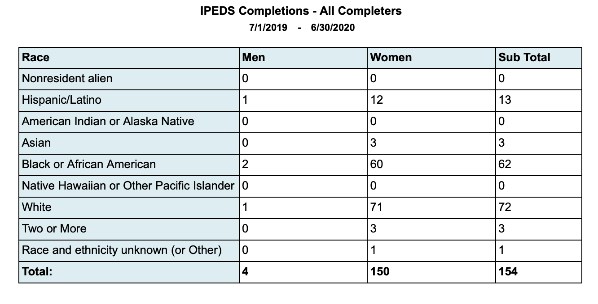
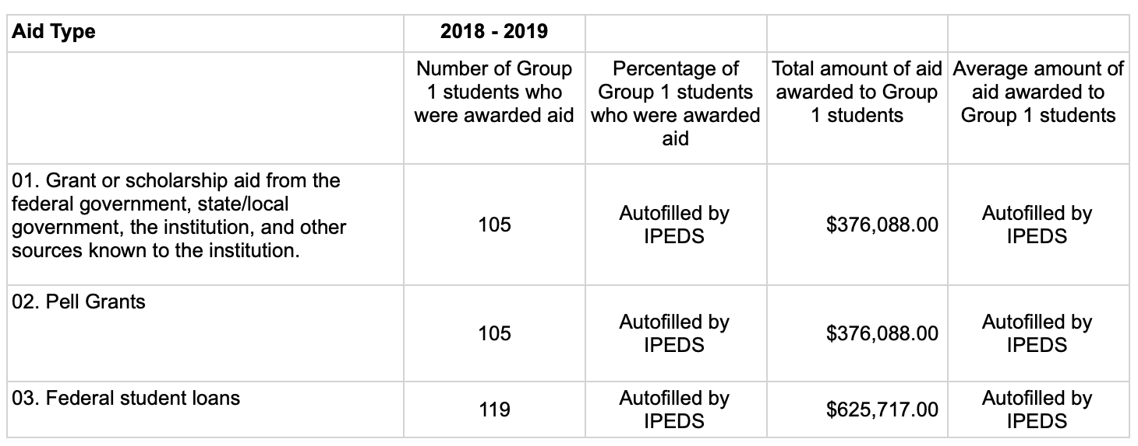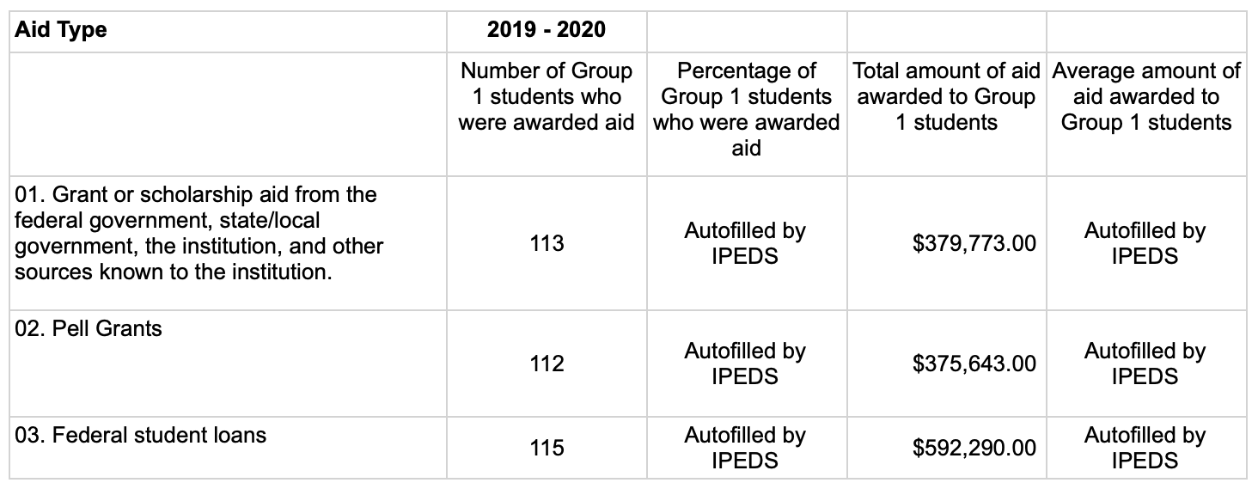

CONSTITUTION DAY

Section 111 of Federal Student Aid Guidelines requires that Constitution Day be held on September 17 of each year, commemorating the September 17, 1787 signing of the Constitution. Constitution Day shall be held during the preceding or following week if Constitution Day falls on a Saturday, Sunday, or holiday. Southeastern Esthetics Institute celebrates Constitution Day by providing a potluck lunch for students, along with allowing students the opportunity to dress appropriately for the event.

STUDENTS UTILIZING VETERANS AFFAIRS FUNDING
● VA students utilizing Chapter 31 or 33 benefits for tuition costs at Southeastern Esthetics Institute will not have penalties, late fees, denial of access to classes or facilities imposed upon them due to delayed disbursement funding from the VA under Chapter 31 or 33.
● VA students must submit a certificate of eligibility for entitlement to educational assistance no later than the first day of a course of education, and submit a written request to the institution to use such entitlement.
● VA students must provide additional information necessary to the proper certification of enrollment as requested by the institution.
● VA students who do not meet full eligibility under their education benefit disbursement are responsible for the remaining balance on their tuition invoice. The remaining balance may be covered under Financial Aid if the student’s total cost of attendance calculation exceeds their actual tuition costs.

SOCIAL MEDIA POLICY

At Southeastern Esthetics Institute, teachers, students, staff, and other school community members use social networking/media (Twitter, Facebook, Instagram, blogs, etc.) as a way to connect with others, share educational resources, create educational content, enhance the classroom experience, and network within and outside of the school community. While social networking is fun and valuable, there are some risks we need to keep in mind when using these tools. In the social media world, the lines are often blurred between what is public or private, personal or professional.

Social media refers to online tools and services that allow any Internet user to create and publish content. Many of these sites use personal profiles where users post information about themselves. Social media allows those with common interests to share content easily, expanding the reach of their ideas and work. Popular social media tools include Facebook, Twitter, LinkedIn, blogs, YouTube and Flickr to name a few.

Below are guidelines to follow when members of the school community (students, faculty, administrators, and staff) are representing Southeastern Esthetics Institute in social media spaces, regardless of whether these are considered professional or personal spaces.

Use Good Judgment
● We expect good judgment in all situations. Behave in a way that will make you and others proud and reflect well on the school.
● Know and follow the school’s Community of Respect and Responsible Computer Use Policy (noted at the end of this page under Additional Resources).
● Regardless of your privacy settings, assume that all of the information you have shared on your social network is public information.
Be Respectful
● Always treat others in a respectful, positive, and considerate manner.
Be Responsible and Ethical
● Because you represent the school, please stick to discussing only those school-related matters that are within your area of responsibility.
● Adults should be open about their affiliation with the school and the role/position they hold.
● If you are someone’s peer, interact with them online if you are so inclined. If you are an employee thinking about interacting with a student, consider the following questions before proceeding. What is the purpose of my interaction with a student? (If it is not related to your classroom activities, reconsider using a social network.) What is the social network in which I propose to interact with a student? (If the social network in question has limited professional applications – Facebook, for instance – reconsider using that social network.) If you are uncertain how to proceed, consult your division head.
● Share and interact in a way that will enhance your reputation, the reputation of others, and the reputation of the school, rather than damage them.
Be a Good Listener
● Keep in mind that one of the biggest benefits of social media is that it gives others another way to talk to you, ask questions directly, and share feedback.
● Be responsive to others when conversing online. Provide answers, thank people for their comments, and ask for further feedback, etc.
Be Accurate and Appropriate
● Check all work for correct use of grammar and spelling before posting.
● A significant part of the interaction on blogs, Twitter, Facebook, and other social networks involves passing on interesting content or sharing links to helpful resources. However, never blindly repost a link without looking at the content first.
And if you don’t get it right ...
● Be sure to correct any mistake you make immediately, and make it clear what you’ve done to fix the mistake.
● Apologize for the mistake if the situation warrants it.
● If it’s a major mistake (e.g., exposing private information or reporting confidential information), please let your Instructor know immediately so the school can take the proper steps to help minimize the impact it may have.
Be Confidential
● Do not publish, post, or release information that is considered confidential or private. Online “conversations” are never private.
● Use caution if asked to share your birth date, address, and cell phone number on any website.
Respect Private and Personal Information
● To ensure your safety, be careful about the type and amount of personal information you provide.
● Avoid talking about personal schedules or situations.
● Never share or transmit personal information of students, parents, faculty, staff, or colleagues online.
● While taking care when posting to safeguard people’s privacy, be sure – as necessary and appropriate – to give proper credit to sources. In cases of doubt, privacy should be the default.
● Generally, use only first names of students. There may be special circumstances where a student is widely known for a particular achievement, in which case the use of the full name may be appropriate. If there is any doubt, use only first names or ask the Director of Community and Media Relations for guidance.
● Always respect the privacy of school community members.
Post Images with Care
● Respect brand, trademark, copyright information and/or images of the school.
● Do not caption photos with the names of current students.

DATA SECURITY PLAN (DSP)

This Data Security Plan for Southeastern Esthetics Institute describes safeguards to protect data, information, and resources. These safeguards are provided to:
• Enable due diligence to ensure the security and confidentiality of covered data, information, and resources
• Protect against anticipated threats or hazards to the security or integrity of such information
• Protect against unauthorized access to or use of covered data, information, and resources that could result in substantial harm or inconvenience
This Data Security Plan also provides for mechanisms to identify and assess the risks that may threaten covered data, information, and resources. Manage and control these risks; implement and review the plan; and adjust the plan to reflect changes in technology, the sensitivity of covered data, information and resources, and internal or external threats to information security. Focus for this document is on the System Network and information on that system located on premise for the Southeastern Esthetics Institute.

Information Security Contacts
Asset Role Name Phone Number Email
Primary Contact | Brandon Sykes | 803-556-2360 | brandon@seestheticsinstitute.com
Secondary Contact | Courtney Sykes | 803-629-0658 | info@seestheticsinstitute.com

CONFIDENTIAL Data Protection

Special care and awareness are required regarding Confidential data. Confidential data is any data that the unwarranted and/or unauthorized disclosure of such would have an adverse effect on the institution or individuals to which it pertains. Unauthorized disclosure or mishandling of sensitive data can be a violation of federal and state law and the institution and its employees can be held personally liable for damages or remediation costs.

Data related to identity theft such as social security number (SSN), credit card numbers, bank account information, driver’s license, name, address, birthdate, passwords, Personal Identification Numbers (PINs), and ID pictures are of concern as all or most of this information is collected in the course of business. Other types of data such as medical information, tax returns, donor information, mailing lists, scholarship information, financial information, and bidding information are examples of data that could require confidential handling or restricted access. These examples are not exhaustive or all inclusive. It is the responsibility of Southeastern Esthetics Institute’s employees handling any Southeastern Esthetics Institute data to understand what data are sensitive and confidential and to adhere to the following guidelines and any applicable regulations.
• Do not collect and/or store SSNs unless it is required by a federal or state agency and there is no other option in terms of unique identifier.
• Data should be stored in as few places as possible and duplicated only when necessary. Unless absolutely necessary, data should be stored on the system only.
• Avoid storing data on departmental servers or creating "silo" databases that duplicate data
• Never upload, post, or otherwise make available any kind of confidential data on a web server even for short periods of time. Individuals responsible for maintaining web site content must be particularly cognizant and vigilant regarding this matter.
• Inventory and identify the data under your control that is external to central administrative systems. Know where you have data and in what form (electronic, paper, etc.). Purge or delete data files in a timely manner to minimize risk.
• Do not store confidential data on or copy it to mobile, external systems, and/or removable storage devices. This may include smartphones, tablets, or any other device that could easily be lost, stolen or compromised. Southeastern Esthetics Institute also restricts the use of organization-controlled portable storage devices on external systems unless authorized by management.
• Do not store confidential data on or copy it to local workstations or network drives unless such data is not available on centralized systems.
• Know and understand your environment technically. Understand who has access to areas to which you send, receive, store, or transmit data.
• Transmission of any sensitive/confidential data should be encrypted. Websites should use HTTPS (TLS 1.2 or greater) encryption if they collect data. Unencrypted protocols should be abandoned in favor of their encrypted counterparts (i.e. abandon Telnet in favor of SSH or abandon FTP in favor of SFTP).
• Do not release Southeastern Esthetics Institute’s data of any kind to a 3rd party unless such entities have agreed in writing to restrict the use of such data to the specific and intended purposes authorized by Southeastern Esthetics Institute’s management enlisting the services of the 3rd party entity. Any Southeastern Esthetics Institute employee releasing data to a 3rd party entity is responsible for how the data is used (or misused). Release of highly sensitive and confidential data (beyond FERPA allowed "directory information") is prohibited.
• Do not send, receive, or store any sensitive data using email under any circumstances. Email is not secure.
• Report any breaches, compromises, or unauthorized/unexplained access of confidential data immediately to management.
Please Note - Confidential data may also be referred to as:
Controlled Unclassified Information (CUI) - Those types of information for which laws, regulations, or governmentwide policies require or permit agencies to exercise safeguarding or dissemination controls.

Privacy Statement

1. Southeastern Esthetics Institute endeavors to ensure that its treatment, custodial practices, and uses of "Personal Information" are in full compliance with all related federal and state statutes and regulations.
2. Southeastern Esthetics Institute commits to take reasonable precautions to maintain privacy and security of students' and employees' personal information. Southeastern Esthetics Institute cannot guarantee that these efforts will always be successful; therefore, users must assume the risk of a breach of Southeastern Esthetics Institute’s privacy and security systems.
3. Southeastern Esthetics Institute does not intend to sell, or otherwise disclose for commercial purposes, outside the scope of ordinary Southeastern Esthetics Institute functions, students' and employees' name, mailing address, telephone number, e-mail address, or other information. While Southeastern Esthetics Institute makes reasonable efforts to protect information provided to us, we cannot guarantee that this information will remain secure and are not responsible for any loss or theft.
4. Personally Identifiable Information is defined as data or other information, which is tied to, or which otherwise identifies, an individual or provides information about an individual in a way that is reasonably likely to enable identification of a specific person and make personal information known about them.
5. Personal information includes, but is not limited to, information regarding a person's social security number, driver's license, marital status, financial information, credit card numbers, bank accounts, parental status, gender, race, religion, political affiliation, personal assets, medical conditions, medical records, and personnel or student records.
6. Some data items are considered directory information and will be released to the public unless a request is filed to prevent disclosure of the information, except for any other reason than official business. Employees who request confidentiality of that information should contact management; and students should contact their admissions contact.
7. Southeastern Esthetics Institute strongly discourages the use or storage (electronic/paper) of SSNs in the course of daily academic or administrative business.
8. Southeastern Esthetics Institute assumes that failure on the part of any student or employee to specifically request the withholding of categories of information indicates individual approval for disclosure.
9. Southeastern Esthetics Institute is bound by the Family Educational Rights and Privacy Act (FERPA) regarding the release of student education records, and in the event of a conflict with Southeastern Esthetics Institute’s policies, FERPA will govern.
FAMILY EDUCATIONAL RIGHTS AND PRIVACY ACT (FERPA)

Notification of Rights
The Family Educational Rights and Privacy Act (FERPA) affords students certain rights with respect to their education records, including:
1. The right to inspect and review the student's education records within 45 days of the day the Southeastern Esthetics Institute receives a request for access. Students should submit to the CEO and/or CAO a written request that identifies the record(s) they wish to inspect. Southeastern Esthetics Institute’s official will make arrangements for access and notify the student of the time and place where the records may be inspected. If the records are not maintained by Southeastern Esthetics Institute’s official to whom the request was submitted, that official shall advise the student of the correct official to whom the request should be addressed.

2. The right to request that inaccurate or misleading information in the student’s record be amended. Students may ask Southeastern Esthetics Institute to amend a record that they believe is inaccurate or misleading. They should write the Southeastern Esthetics Institute’s official responsible for the record, clearly identify the part of the record they want changed and specify why it is inaccurate or misleading. If Southeastern Esthetics Institute decides not to amend the record as requested by the student, Southeastern Esthetics Institute will notify the student of the decision and advise the student of his or her right to a hearing regarding the request for amendment. Additional information regarding the hearing procedures will be provided to the student when notified of the right to a hearing.

3. The right to consent to disclosures of personally identifiable information contained in the student's education records, except to the extent that FERPA authorizes disclosure without consent, including:
• Disclosure without the student's consent is permissible to school officials with legitimate educational interests. A school official is a person employed by Southeastern Esthetics Institute in an administrative, supervisory, academic, research, or support staff position (including law enforcement unit personnel and health staff); a person or company with Southeastern Esthetics Institute has contracted (such as an attorney, auditor, or collection agent); a person serving on the Board of Regents; or a student serving on an official committee, such as a disciplinary or grievance committee, or assisting another school official in performing his or her tasks. A school official has a legitimate educational interest if the official needs to review an education record in order to fulfill his or her professional responsibility.
• FERPA allows the institution to routinely release information defined as "directory information." The following student information is included in the definition: the student's name, address, e-mail address, telephone listing, date and place of birth, major field of study, participation in officially recognized activities and sports, weight and height of members of athletic teams, dates of attendance, enrollment status (including full-time, part-time, not enrolled, withdrawn and date of withdrawal), degree and awards received, and the most recent previous education agency or institution attended by the student. When a student wants any part of the directory information to remain confidential, an official request form must be completed in the Office of the Registrar within the first five days of class of each school term.

The right to file a complaint with the U.S. Department of Education concerning alleged failures by Southeastern Esthetics Institute to comply with the requirements of FERPA. The name and address of the Office that administers FERPA is:
Family Policy Compliance Office U.S. Department of Education 400 Maryland Avenue, S.W. Washington, DC 20202-5920

Student Catalog
Acknowledgement of Receipt

I acknowledge that I have read the Southeastern Esthetics Institute Student Catalog in its entirety and fully understand its contents. I acknowledge that the rules and regulations with the Student Catalog are subject to change and I will be informed when updates are made for my review. I understand that I am responsible for the policies and procedures within the Student Catalog at all times.
If I have questions, I will contact the appropriate Southeastern Esthetics Institute representative.

Student Name (Print): ____________________________________________________________________
Student Signature: _______________________________________________________________________
Date: _____________________________________________________________________________________

__________________________________________ ____________________________
Administrative Signature Date

